PRESS RELEASE

New E+E transmitter for intrinsically safe industrial applications

Safe measurement of humidity and temperature in explosion hazard areas

(Engerwitzdorf, xx.02.2013) The new EE300Ex humidity / temperature transmitter from E+E Elektronik has been specially developed for challenging industrial applications. The device conforms to the ATEX Directives for intrinsically safe equipment, and can be used in both gas and dust explosion hazard areas.

Thanks to its easy-to-clean, elegant stainless steel housing, the humidity transmitter is ideal for use in the pharmaceutical and chemicals industry. The EE300Ex can be mounted directly in the explosion hazard area of zones 0 / 20. The tried and trusted E+E humidity probe provides long-term stability as well as precise and reliable measurements in the 0…100% rel. hum. and -40…180°C and from 0.01…300bar under pressure.

The 2-part housing concept (separation of the connection area and measurement unit) simplifies more than the installation of the humidity transmitter. It also permits the rapid replacement of the measurement unit - such as for calibration - without time-consuming re-cabling.

The EE300Ex offers a high level of flexibility thanks to various versions. As a compact version for wall mounting or with an up to 10m remote measurement sensing probe, the humidity transmitter is ideal for a wide range of applications. The current values can be read off the device directly using the optional display.

Just as with humidity measurement in air, the EE300Ex can also be used for moisture measurement in oils. The humidity content of an oil can be issued as absolute in [ppm] or relative as water content [aw]. Typical applications are found in systems for cleaning/drying oil or on oil platforms for online monitoring of lubrication and gear oils.

The EE300Ex is designed using 2-conductor technology. The measured values are issued on 2 analogue outputs with 4…20mA. The power can be supplied via any intrinsically safe power supply device. In addition to the measured values for humidity and temperature, the dewpoint, frost point, absolute humidity, mixing ratio and other computational functions can also be issued.

The configuration adapter can be used to carry out custom modifications of the transmitter and to adjust the humidity and temperature outputs quickly and easily.

In addition to the applications given above, the EE300Ex is ideal for use in power stations, grain mills or explosion hazard storage rooms.

Characters: 2098 (excluding spaces)
Words: 383

Images:

Figure 1:
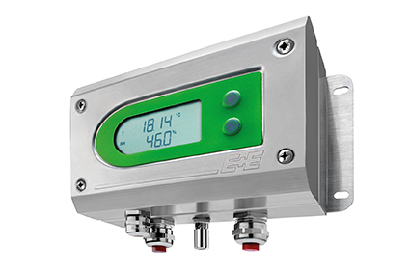

Safe: The EE300Ex humidity/ temperature transmitter can be mounted directly in explosion hazard areas.

Figure 2:
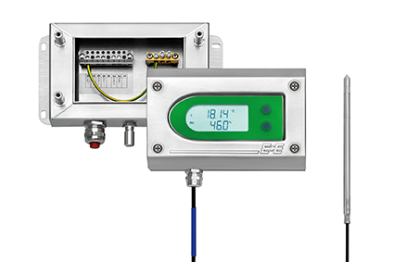

Ingenious: The separation of the connection area and measurement unit, the EE300Ex can be installed quickly and easily.

Figure 3:
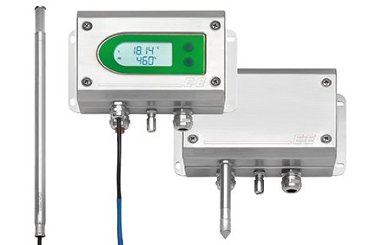
Flexible: Thanks to various versions the EE300Ex offers a high level of flexibility.

Photos: E+E Elektronik GmbH, reprint free of charge

About E+E Elektronik:
E+E Elektronik GmbH, with headquaters in Engerwitzdorf/Austria, belongs to the Dr. Johannes Heidenhain GmbH group. With around 240 employees, E+E develops and manufactures sensors and transmitters for relative humidity, CO2, air velocity and flow as well as humidity calibration systems. The main E+E markets are HVAC, process control and automotive. With an export share of around 97 % E+E has branch offices in China, Germany, France, Italy, Korea and the USA as well as an international dealer network. Beside operating own accredited calibration laboratories, E+E Elektronik has been appointed by the Austrian Federal Office for Calibration and Measurement (Bundesamt für Eich- und Vermessungswesen; BEV) as designated laboratory to supply the national standards for humidity and air velocity.

Contact:
E+E Elektronik GmbH T: +43 (0) 7235 605-0
Langwiesen 7 F: +43 (0) 7235 605-8
A-4209 Engerwitzdorf info@epluse.at
Austria www.epluse.com

Marketing contact: Mr. Johannes Fraundorfer
Email: johannes.fraundorfer@epluse.at

