PRESS RELEASE

Modbus CO2 probe for demanding OEM applications
(Engerwitzdorf, 5.12.2013) The EE871 CO2 probe from E+E Elektronik is designed for maintenance-free use in demanding OEM applications. The Modbus protocol permits easy retrieval and further processing of measurement values ​​and facilitates simple integration into custom applications.

Highest measurement accuracy
The compact probe measures CO2 concentrations up to 10,000 ppm. Thanks to the multipoint CO2 and temperature adjustment, temperature compensation ensures excellent measurement accuracy over the entire operating range of -40... 60°C.

Excellent long-term stability
The CO2 measurement cell of the probe is based on infrared technology (NDIR) and uses a dual-wavelength auto-calibration procedure. Thus, the EE871 is maintenance free and highly resistant to environmental influences. Ageing effects are automatically compensated, thus ensuring excellent long-term stability.

High resistance to pollution
The IP65 enclosure and the replaceable filter ensure optimal protection from contamination. Therefore, the EE871 can also be used in harsh environmental conditions.

Easy assembly
Its compact design, M12 electrical connector and optional mounting flange facilitate the installation or replacement of the CO2 probe.

Due to its very low power consumption, the CO2 probe is particularly interesting for use in battery-powered devices such as data loggers, handhelds and wireless sensors. Other applications can be found, among others, in greenhouses, stables, fruit and vegetable storage facilities, hatchers and incubators.

Characters: 1.369 (excluding spaces)
Words: 215

Images:
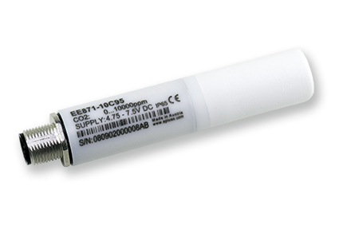
Figure 1: EE871 Modbus CO2 probe from E+E Elektronik.

Photos: E+E Elektronik GmbH, reprint free of charge

About E+E Elektronik:
E+E Elektronik GmbH, with headquaters in Engerwitzdorf/Austria, belongs to the Dr. Johannes Heidenhain GmbH group. With around 240 employees, E+E develops and manufactures sensors and transmitters for relative humidity, CO2, air velocity and flow as well as humidity calibration systems. The main E+E markets are HVAC, process control and automotive. With an export share of around 97 % E+E has branch offices in China, Germany, France, Italy, Korea and the USA as well as an international dealer network. Beside operating own accredited calibration laboratories, E+E Elektronik has been appointed by the Austrian Federal Office for Calibration and Measurement (Bundesamt für Eich- und Vermessungswesen; BEV) as designated laboratory to supply the national standards for humidity and air velocity.

Contact:
E+E Elektronik GmbH T: +43 (0) 7235 605-0
Langwiesen 7 F: +43 (0) 7235 605-8
A-4209 Engerwitzdorf info@epluse.at
Austria www.epluse.com

Marketing contact: Mr. Johannes Fraundorfer
Email: johannes.fraundorfer@epluse.at

