PRESS RELEASE

E+E Elektronik wins large contract for humidity transmitters

The National Meteorological Service of Germany relies on sensor technology from Austria
(Engerwitzdorf, 4. 7. 2013) The Austrian sensor specialist E+E Elektronik wins the contract from the National Meteorological Service of Germany (Deutscher Wetterdienst; DWD) to equip its weather stations with new humidity/temperature transmitters.

As the national meteorological service for the Federal Republic of Germany, the DWD is the nation's highest authority for meteorology, weather and climate and operates almost 2000 weather monitoring points and stations. All previous humidity transmitters across the entire measurement network are to be replaced by 2015. The high-end transmitters deliver precise measurement results for exact weather and climate forecasts.

The humidity/temperature transmitters in use here are the EE33 series (type J). The devices feature high-precision and reliable measurement results even under the most challenging of ambient conditions. At the heart of this transmitter is the monolithic HMC01 measurement cell developed by E+E using thin-layer technology. Thanks to the unique E+E sensor coating, the measurement cell is optimally protected against condensation and chemical contamination. This was a factor that also persuaded the Royal Netherlands Meteorological Institute (KNMI) to procure these transmitters for themselves.

Previously humidity and temperature were each recorded using a separate transmitter. With the new humidity/temperature transmitters from E+E Elektronik, both these measurements can now be taken using a single instrument. A further benefit: measurement results will in future be transmitted digitally, not via analogue means.

All instruments are manufactured at the Austrian company's site in Engerwitzdorf. The first hundred transmitters are scheduled to ship during August 2013.

E+E Elektronik itself operates a state-accredited calibration lab and holds the National Standards for relative air humidity and air flow velocity in Austria on behalf of the Federal Office for Metrology and Surveying (Bundesamt für Eich- und Vermessungswesen; BEV).

Characters: 1862 (excluding spaces)
Words: 301

Images:

Figure 1:

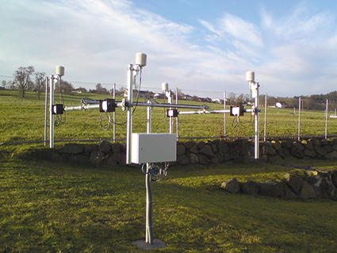

E+E weather monitoring station with EE33-J humidity/temperature transmitters.

Photos: E+E Elektronik GmbH, reprint free of charge

About E+E Elektronik:
E+E Elektronik GmbH, with headquaters in Engerwitzdorf/Austria, belongs to the Dr. Johannes Heidenhain GmbH group. With around 240 employees, E+E develops and manufactures sensors and transmitters for relative humidity, CO2, air velocity and flow as well as humidity calibration systems. The main E+E markets are HVAC, process control and automotive. With an export share of around 97 % E+E has branch offices in China, Germany, France, Italy, Korea and the USA as well as an international dealer network. Beside operating own accredited calibration laboratories, E+E Elektronik has been appointed by the Austrian Federal Office for Calibration and Measurement (Bundesamt für Eich- und Vermessungswesen; BEV) as designated laboratory to supply the national standards for humidity and air velocity.

Contact:
E+E Elektronik GmbH T: +43 (0) 7235 605-0
Langwiesen 7 F: +43 (0) 7235 605-8
A-4209 Engerwitzdorf info@epluse.at
Austria www.epluse.com

Marketing contact: Mr. Johannes Fraundorfer
Email: johannes.fraundorfer@epluse.at

