PRESS RELEASE
New humidity and temperature transmitter from E+E Elektronik
Highly accurate humidity and temperature measurement for demanding climate control

(Engerwitzdorf, 17.03.2014) The new EE210 transmitter from E+E Elektronik has been developed for highly accurate measurement of relative humidity and temperature in demanding climate control applications. Excellent temperature compensation ensures outstanding accuracy over the entire temperature working range.

Besides relative humidity and temperature, EE210 calculates further physical quantities such as dew point temperature, absolute humidity and mixing ratio. Two of the measured and calculated values are available on the freely configurable analogue voltage or current outputs.

The combination of completely encapsulated measurement electronics inside the sensing probe and HCT01 humidity sensor with E+E proprietary protective coating enables the use of the EE210 even under harsh and aggressive environmental conditions.

The innovative enclosure of the EE210 provides outstanding protection against contamination. Thanks to the external mounting holes the housing remains closed during installation and so the electronics is protected from construction site pollution or mechanical damage. At the same time the installation costs are minimized.

Up to three individually selectable measurement values can be shown simultaneously on the optional display. The smooth cover surface avoids accumulation of dust in protruding edges.

EE210 transmitters are available for wall or duct mounting. Typical applications are agriculture (stables, incubators, hatchers, green houses), storage rooms, cooling chambers or indoor pools.

Characters: 1.452 (excluding spaces)
Words: 223

Images:
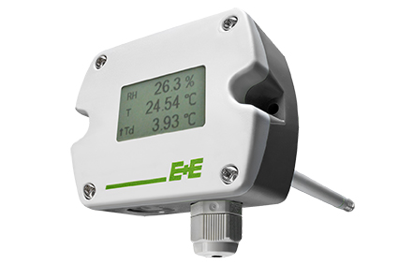
Figure 1: EE210 humidity & temperature transmitter from E+E Elektronik.

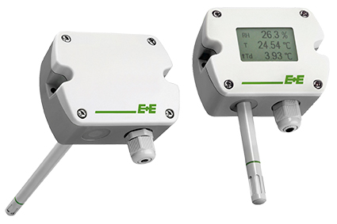
Figure2: EE210 transmitters are available for wall or duct mounting and with optional display.

Photos: E+E Elektronik GmbH, reprint free of charge

About E+E Elektronik:
E+E Elektronik GmbH, with headquaters in Engerwitzdorf/Austria, belongs to the Dr. Johannes Heidenhain GmbH group. With around 250 employees, E+E develops and manufactures sensors and transmitters for relative humidity, CO2, air velocity and flow as well as humidity calibration systems. The main E+E markets are HVAC, process control and automotive. With an export share of around 97 % E+E has branch offices in China, Germany, France, Italy, Korea and the USA as well as an international dealer network. Beside operating own accredited calibration laboratories, E+E Elektronik has been appointed by the Austrian Federal Office for Calibration and Measurement (Bundesamt für Eich- und Vermessungswesen; BEV) as designated laboratory to supply the national standards for humidity and air velocity.

Contact:
E+E Elektronik GmbH T: +43 (0) 7235 605-0
Langwiesen 7 F: +43 (0) 7235 605-8
A-4209 Engerwitzdorf info@epluse.at
Austria www.epluse.com

Marketing contact: Mr. Johannes Fraundorfer
Email: johannes.fraundorfer@epluse.at

