PRESS RELEASE
Perfect for Demanding OEM Applications

Miniature Dew Point Transmitter for Refrigeration Dryers
(Engerwitzdorf, 18.11.2014) The EE354 in-line transmitter from E+E Elektronik is specifically optimized for dew point monitoring of refrigeration dryers. The high accuracy and excellent long-term stability make the transmitter a perfect solution for OEM manufacturers. Due to its compact design and small dimensions the EE354 is ideal for use in harsh applications with space constraints.

The EE354 is suitable for dew point monitoring in the range of -20°...50°C Td (-4...122°F Td). It features a high accuracy of ±1°C (±1.8°F Td) in the typical operating range of a refrigeration dryer (-3...20°C Td / 26.6...68°F Td). The built-in humidity sensor HC1000 is highly resistant to compressor oil and other chemicals. The robust, IP65 stainless steel enclosure is another quality feature of the EE354.

The measured values are available on a analog 4-20 mA output and a digital Modbus RTU interface.
Using the free configuration software and the optional Modbus USB converter the scaling of the analog output can be modified. This also permits one and two-point adjustments by the user.

A ½ "ISO or NPT thread and the standard M12x1 connector for electrical connection all facilitate quick and easy integration into the measuring task.

Characters: 1125 (excluding spaces)
Words: 204

Images:
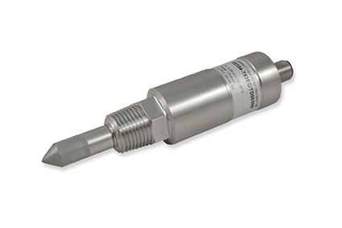
Figure 1: EE354 In-Line Dew Point Transmitter for Refrigeration Dryers

Photos: E+E Elektronik GmbH, reprint free of charge

About E+E Elektronik:
E+E Elektronik GmbH, with headquaters in Engerwitzdorf/Austria, belongs to the Dr. Johannes Heidenhain GmbH group. With over 250 employees, E+E develops and manufactures sensors and transmitters for relative humidity, CO2, air velocity and flow as well as humidity calibration systems. The main E+E markets are HVAC, process control and automotive. With an export share of around 97 % E+E has branch offices in China, Germany, France, Italy, Korea and the USA as well as an international dealer network. Aside from operating its own accredited calibration laboratories, E+E Elektronik has been appointed by the Austrian Federal Office for Calibration and Measurement (Bundesamt für Eich- und Vermessungswesen; BEV) as a designated laboratory to supply the national standards for humidity and air velocity.

Contact:
E+E Elektronik GmbH T: +43 (0) 7235 605-0
Langwiesen 7 F: +43 (0) 7235 605-8
A-4209 Engerwitzdorf info@epluse.at
Austria www.epluse.com

Marketing contact: Mr. Johannes Fraundorfer
Email: johannes.fraundorfer@epluse.at

