PRESS RELEASE

Compact Moisture in Oil Transmitter
Accurate and Reliable Monitoring of Moisture in Industrial Oils

(Engerwitzdorf, 23.09.2014) The EE364 in-line transmitter from E+E Elektronik measures moisture and temperature in transformer, lubricating, hydraulic or motor oils, and diesel fuel. This device can assist in planning condition-based maintenance operations to aid in avoiding equipment breakdown, leading to lowered costs.

The EE364 can measure water activity (a_{w}) and oil temperature (T), and calculate water content (x in ppm). The readings are available on two 4-20 mA analog outputs and a Modbus RTU interface. The analog outputs can be scaled and configured by the user with the optional converter cable and free configuration software.

The EE364 is pressure rated to 20 bar (290 psi) and features G ½" ISO or ½" NPT process connection threads. Its compact size and robust stainless steel IP65 enclosure allow for easy integration into demanding OEM applications and harsh environmental conditions.

Characters: 853 (excluding spaces)
Words: 151

Images:
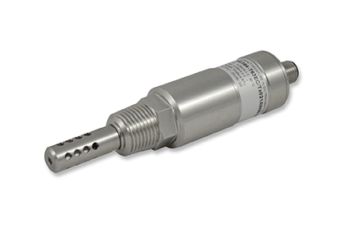
Figure 1: Compact moisture in oil transmitter EE364 from E+E Elektronik.

Photos: E+E Elektronik GmbH, reprint free of charge

About E+E Elektronik:
E+E Elektronik GmbH, with headquaters in Engerwitzdorf/Austria, belongs to the Dr. Johannes Heidenhain GmbH group. With around 250 employees, E+E develops and manufactures sensors and transmitters for relative humidity, CO2, air velocity and flow as well as humidity calibration systems. The main E+E markets are HVAC, process control and automotive. With an export share of around 97 % E+E has branch offices in China, Germany, France, Italy, Korea and the USA as well as an international dealer network. Aside from operating its own accredited calibration laboratories, E+E Elektronik has been appointed by the Austrian Federal Office for Calibration and Measurement (Bundesamt für Eich- und Vermessungswesen; BEV) as a designated laboratory to supply the national standards for humidity and air velocity.

Contact:
E+E Elektronik GmbH T: +43 (0) 7235 605-0
Langwiesen 7 F: +43 (0) 7235 605-8
A-4209 Engerwitzdorf info@epluse.at
Austria www.epluse.com

Marketing contact: Mr. Johannes Fraundorfer
Email: johannes.fraundorfer@epluse.at

