PRESS RELEASE
Made for mass applications

New Miniature Air Flow Transmitter for HVAC
(Engerwitzdorf, 27.08.2014) The new transmitter EE671 measures air velocity up to 20 m/s. Thanks to its compact design it is ideal for mass applications in HVAC. The flow sensing element sets new standards in terms of accuracy and resistance to pollutants.

The built-in VTQ flow sensing element based on thin-film technology works on the hot-film anemometer principle. Thanks to its innovative design - made possible by the use of the latest transfer molding technology - the sensor is particularly resistant to contamination. A high reproducibility of the sensor characteristics, fast response time, low angle dependence and excellent long-term stability are further advantages of the high-quality sensing element.

The EE671 is available with cable or plug connection. An alignment strip on the probe and matching mounting flange simplifies installation and ensures proper alignment of the sensor. The flange enables the immersion depth to be infinetly variable.

The measured air velocity is available as linear voltage output (optional 0-1V, 0-5V or 0-10V). The digital interface in combination with a configuration kit allows the customer to set the measurement range, to configure the output signal and to adjust the transmitter.

The EE671 is suitable for use in heating and ventilation systems, for flow monitoring and control or for inlet air monitoring in ovens.

Characters: 1,220 (excluding spaces)
Words: 221

Images:
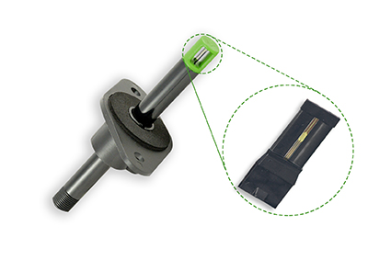
Figure 1: EE671 air flow transmitter for mass applications.

Photos: E+E Elektronik GmbH, reprint free of charge

About E+E Elektronik:
E+E Elektronik GmbH, with headquaters in Engerwitzdorf/Austria, belongs to the Dr. Johannes Heidenhain GmbH group. With around 250 employees, E+E develops and manufactures sensors and transmitters for relative humidity, CO2, air velocity and flow as well as humidity calibration systems. The main E+E markets are HVAC, process control and automotive. With an export share of around 97 % E+E has branch offices in China, Germany, France, Italy, Korea and the USA as well as an international dealer network. Aside from operating its own accredited calibration laboratories, E+E Elektronik has been appointed by the Austrian Federal Office for Calibration and Measurement (Bundesamt für Eich- und Vermessungswesen; BEV) as a designated laboratory to supply the national standards for humidity and air velocity.

Contact:
E+E Elektronik GmbH T: +43 (0) 7235 605-0
Langwiesen 7 F: +43 (0) 7235 605-8
A-4209 Engerwitzdorf info@epluse.at
Austria www.epluse.com

Marketing contact: Mr. Johannes Fraundorfer
Email: johannes.fraundorfer@epluse.at

