PRESS RELEASE

Modular CO2 transmitter for demanding OEM applications
(Engerwitzdorf, 21.01.2014) The modular CO2 transmitter EE870 from E+E Elektronik is designed for maintenance-free use in demanding OEM applications. It offers various analogue outputs, Modbus interface, and a wide range of AC and DC supply voltage ranges.

The compact, interchangeable probe measures CO2 concentrations up to 10,000 ppm and can be replaced within seconds without the need of calibration or adjustment. The user can change the measuring range of EE870 by simply plugging in another probe.

The probe is based on infrared technology (NDIR) and uses a dual wavelength auto-calibration procedure. Thus, it is completely maintenance free and highly resistant to environmental influences.

Thanks to the factory multipoint CO2 and temperature adjustment, temperature compensation ensures excellent measurement accuracy over the entire operating range of -40... 60°C.

Due to the probe’s very high resistance to pollution, the EE870 is particularly suitable for use in harsh conditions, such as greenhouses, stables, fruit and vegetable storage facilities, hatchers and incubators.

Advantages at a glance:
- Excellent long-term stability via auto-calibration
- Highest measurement accuracy due to temperature compensation
- High resistance to pollution thanks to the IP65 housing and replaceable filter
- Easy installation and service due to modular design

Characters: 1.215 (excluding spaces)
Words: 204

Images:
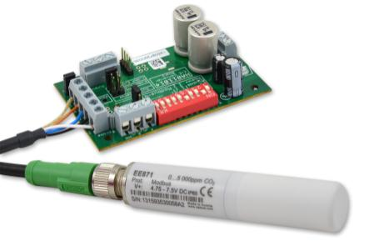

Figure 1: EE870 Modular CO2 transmitter from E+E Elektronik.

Photos: E+E Elektronik GmbH, reprint free of charge

About E+E Elektronik:
E+E Elektronik GmbH, with headquaters in Engerwitzdorf/Austria, belongs to the Dr. Johannes Heidenhain GmbH group. With around 250 employees, E+E develops and manufactures sensors and transmitters for relative humidity, CO2, air velocity and flow as well as humidity calibration systems. The main E+E markets are HVAC, process control and automotive. With an export share of around 97 % E+E has branch offices in China, Germany, France, Italy, Korea and the USA as well as an international dealer network. Beside operating own accredited calibration laboratories, E+E Elektronik has been appointed by the Austrian Federal Office for Calibration and Measurement (Bundesamt für Eich- und Vermessungswesen; BEV) as designated laboratory to supply the national standards for humidity and air velocity.

Contact:
E+E Elektronik GmbH T: +43 (0) 7235 605-0
Langwiesen 7 F: +43 (0) 7235 605-8
A-4209 Engerwitzdorf info@epluse.at
Austria www.epluse.com

Marketing contact: Mr. Johannes Fraundorfer
Email: johannes.fraundorfer@epluse.at

