PRESS RELEASE
Maintenance-free, highly accurate, compact

CO2 Sensor Module designed for OEM Applications
(Engerwitzdorf, 08.04.2014) The sensor module EE893 from E+E Elektronik allows highly accurate and long-term stable CO2 measurements in demanding OEM applications. Thanks to its very small size and low power consumption, EE893 can be used in both hard wired sensors and battery operated devices such as wireless transmitters, hand-helds and data loggers.

The dual wavelength NDIR measuring principle is maintenance free and highly insensitive to environmental influences. Aging effects are automatically compensated.

The multiple point CO2 and temperature adjustment ensures excellent accuracy over the entire temperature working range. The CO2 measurements with a measuring range up to 10,000 ppm are available on the digital E2 interface. The measurement interval can be set individually according to the requirements of the application.

Characters: 800 (excluding spaces)
Words: 133

Images:
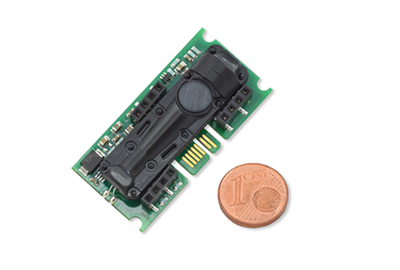
Figure 1: Sensor Module EE893 from E+E Elektronik.

Photos: E+E Elektronik GmbH, reprint free of charge

About E+E Elektronik:
E+E Elektronik GmbH, with headquaters in Engerwitzdorf/Austria, belongs to the Dr. Johannes Heidenhain GmbH group. With around 250 employees, E+E develops and manufactures sensors and transmitters for relative humidity, CO2, air velocity and flow as well as humidity calibration systems. The main E+E markets are HVAC, process control and automotive. With an export share of around 97 % E+E has branch offices in China, Germany, France, Italy, Korea and the USA as well as an international dealer network. Beside operating own accredited calibration laboratories, E+E Elektronik has been appointed by the Austrian Federal Office for Calibration and Measurement (Bundesamt für Eich- und Vermessungswesen; BEV) as designated laboratory to supply the national standards for humidity and air velocity.

Contact:
E+E Elektronik GmbH T: +43 (0) 7235 605-0
Langwiesen 7 F: +43 (0) 7235 605-8
A-4209 Engerwitzdorf info@epluse.at
Austria www.epluse.com

Marketing contact: Mr. Johannes Fraundorfer
Email: johannes.fraundorfer@epluse.at

