PRESS RELEASE
E+E Elektronik at the Electronica 2014 trade fair (hall B1, booth 415)

(Engerwitzdorf, 11.11.2014) Since 1979 Austrian sensor specialist E+E Elektronik has been developing high precision sensors and transmitters for a variety of measurements. The company combines its many years of experience in thin-film technology with the latest production processes and the highest quality standards. The result is innovative and reliable products for particularly demanding applications in industry, HVAC or the automobile sectors. Visitors to the E+E booth in hall B1 / booth 415 will have the opportunity to find out about the following new developments:

Contamination-resistant air velocity sensor for demanding applications
The new VTQ is a thin-film sensor, combined with the latest transfer molding technology. Its innovative flow profile gives the sensor element a particularly high level of contamination resistance. The VTQ is therefore ideal for use in harsh conditions. Other features of the sensor include outstanding reproducibility of the sensor characteristics, rapid response time, low angle dependence and a wider measurement range up to 20 m/s.

Next generation miniature humidity sensor
With the HC801, E+E Elektronik presents its smallest humidity sensor for mass applications to date. The miniature sensor is manufactured in thin-film technology based on silicon and is only 300 x 765 μm in size. Maximum reproducibility of the sensor characteristics and linearity across the entire measurement range, as with all humidity sensors in the HC series, are further benefits of the new sensor element.

Compact CO₂ sensor module for OEM applications
The digital EE893 CO₂ sensor module is based on the NDIR dual wavelength procedure and was developed especially for OEM applications. Autocalibration and temperature compensation ensure long-term stability and high precision measurement results. Thanks to its very small dimensions and low power consumption, the module is suitable for use in battery-operated devices such as wireless transmitters, hand-held transmitters or data loggers.

HVAC humidity & temperature transmitter for duct mounting
With the EE150, E+E Elektronik is launching a compact humidity & temperature transmitter optimised for the HVAC sector. Thanks to the external mounting holes, the transmitter housing remains closed during the mounting process. The electronic components are therefore optimally protected against contamination on the construction site. The high precision E+E humidity sensor wins out with exceptional long-term stability and high resistance to pollution.

Characters: 2226 (excluding spaces)
Words: 378

Images:
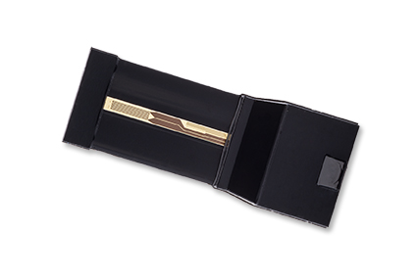
Figure 1: VTQ air velocity sensor.

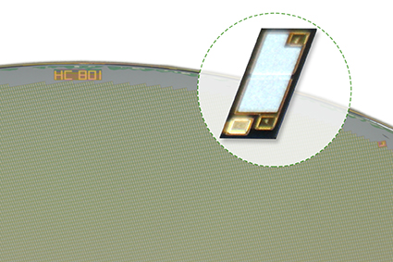
Figure 2: Miniature humidity sensor HC801 for mass applications.

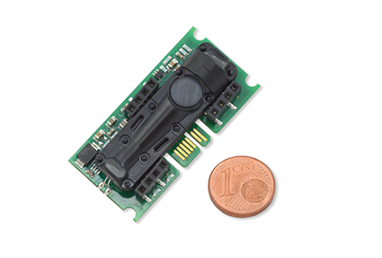
Figure 3: EE893 CO₂ sensor module for OEM applications.

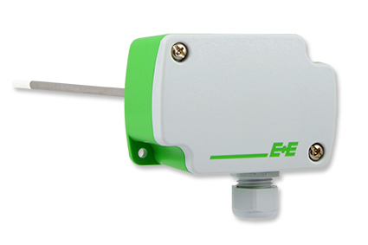
Figure 3: EE150 humidity & temperature transmitter for the HVAC sector.

Photos: E+E Elektronik GmbH, reprint free of charge

About E+E Elektronik:
E+E Elektronik GmbH, with headquaters in Engerwitzdorf/Austria, belongs to the Dr. Johannes Heidenhain GmbH group. With around 250 employees, E+E develops and manufactures sensors and transmitters for relative humidity, CO₂, air velocity and flow as well as humidity calibration systems. The main E+E markets are HVAC, process control and automotive. With an export share of around 97 % E+E has branch offices in China, Germany, France, Italy, Korea and the USA as well as an international dealer network. Aside from operating its own accredited calibration laboratories, E+E Elektronik has been appointed by the Austrian Federal Office for Calibration and Measurement (Bundesamt für Eich- und Vermessungswesen; BEV) as a designated laboratory to supply the national standards for humidity and air velocity.

Contact:
E+E Elektronik GmbH T: +43 (0) 7235 605-0
Langwiesen 7 F: +43 (0) 7235 605-8
A-4209 Engerwitzdorf info@epluse.at
Austria www.epluse.com

Marketing contact: Mr. Johannes Fraundorfer
Email: johannes.fraundorfer@epluse.at

