PRESS RELEASE
Moisture in Oil Measurement Made Easy

Hand-held Meter for Moisture Content of Industrial Oils
(Engerwitzdorf, 21.10.2014) The new hand-held meter OILPORT 30 from E+E Elektronik accurately measures the water activity (aw) and temperature (T), and calculates the absolute water content x (ppm) of industrial oils. The user can store up to ten sets of oil specific parameters in the hand-held to be used for correct calculations of the water content in various oils.

The large touch screen display and intuitive navigation menu ensure comfortable operation of the OILPORT 30. With the data logging function, the measured values can be stored in the device and are available through the USB interface for further processing. The user can easily perform 1 or 2 point adjustments of aw and T, and use the OILPORT 30 as a reference for checking other measurement devices in the field.

The short oil probe with OILPORT 30 is ideal for measurements in oil samples, while in-line monitoring can be carried out with the pressure-tight probe (up to 20 bar/300 psi). Together with the optional ball valve, the pressure-tight oil probe can be installed and removed without interruption of the oil flow.

The OILPORT 30 is delivered in a hard shell carrying case which accommodates the hand-held device, probe, an optional humidity calibration kit, and accessories.

Characters: 1132 (excluding spaces)
Words: 218

Images:
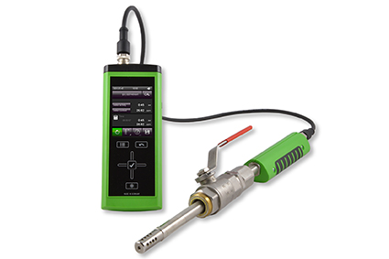
Figure 1: OILPORT 30 hand-held meter with pressure tight probe and ball valve.

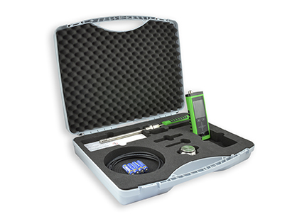
Figure 2: OILPORT 30 set in the hard shell carrying case.

Photos: E+E Elektronik GmbH, reprint free of charge

About E+E Elektronik:
E+E Elektronik GmbH, with headquaters in Engerwitzdorf/Austria, belongs to the Dr. Johannes Heidenhain GmbH group. With around 250 employees, E+E develops and manufactures sensors and transmitters for relative humidity, CO2, air velocity and flow as well as humidity calibration systems. The main E+E markets are HVAC, process control and automotive. With an export share of around 97 % E+E has branch offices in China, Germany, France, Italy, Korea and the USA as well as an international dealer network. Aside from operating its own accredited calibration laboratories, E+E Elektronik has been appointed by the Austrian Federal Office for Calibration and Measurement (Bundesamt für Eich- und Vermessungswesen; BEV) as a designated laboratory to supply the national standards for humidity and air velocity.

Contact:
E+E Elektronik GmbH T: +43 (0) 7235 605-0
Langwiesen 7 F: +43 (0) 7235 605-8
A-4209 Engerwitzdorf info@epluse.at
Austria www.epluse.com

Marketing contact: Mr. Johannes Fraundorfer
Email: johannes.fraundorfer@epluse.at

