PRESS RELEASE
New CO₂ probe for Omniport 30
Hand-held meter from E+E Elektronik now also measures CO₂

(Engerwitzdorf, 17.12.2014) Now available for the Omniport 30 hand-held meter from E+E Elektronik is a CO₂ probe with a measurement range of 0…2000 / 5000 / 10,000ppm. This means that the device can be used for ambient air monitoring or for CO₂ leak localization. Other E+E probes for humidity, temperature and air velocity and the integrated air pressure sensor make the Omniport 30 a universal measuring instrument for a variety of applications. A total of up to 23 different measurements can be recorded and stored.

The new CO₂ probe is based on the NDIR dual wave length procedure and was developed specifically for demanding applications. Auto calibration and temperature compensation ensure long-term stability and high precision measurement results. The CO₂ probe can also be calibrated directly on-site via the hand-held.

The Omniport 30 offers continuous and single-point data logging with time stamp. Up to three measurements can be displayed simultaneously on the large, easy to read TFT display. The data can also be displayed in the form of graphs. The intuitive menu guidance and touchscreen navigation make operating the hand-held easy and user friendly.
The internal memory of the Omniport 30 provides space for up to 2 million measurement values that can be transferred to a PC via USB interface. Complimentary data management software is available to carry out further analysis and archiving. Software updates can also be carried out via the USB interface.

A practical transport case is available for safe storage of the hand-held, including sensing probes and accessories.

Characters: 1341 (excluding spaces)
Words: 251

Images:
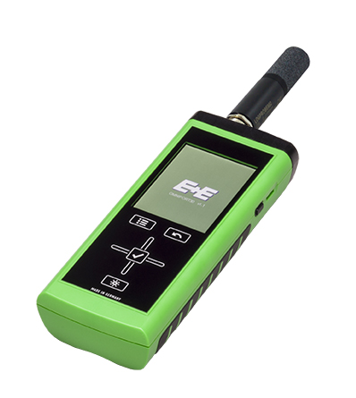
Figure 1: Robust hand-held meter Omniport 30 with CO₂ probe.

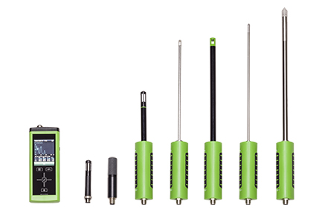
Figure 2: A wide range of interchangeable sensing probes make the Omniport 30 a universally applicable measuring instrument.

Photos: E+E Elektronik GmbH, reprint free of charge

About E+E Elektronik:
E+E Elektronik GmbH, with headquaters in Engerwitzdorf/Austria, belongs to the Dr. Johannes Heidenhain GmbH group. With over 250 employees, E+E develops and manufactures sensors and transmitters for relative humidity, CO₂, air velocity and flow as well as humidity calibration systems. The main E+E markets are HVAC, process control and automotive. With an export share of around 97 % E+E has branch offices in China, Germany, France, Italy, Korea and the USA as well as an international dealer network. Aside from operating its own accredited calibration laboratories, E+E Elektronik has been appointed by the Austrian Federal Office for Calibration and Measurement (Bundesamt für Eich- und Vermessungswesen; BEV) as a designated laboratory to supply the national standards for humidity and air velocity.

Contact:
E+E Elektronik GmbH T: +43 (0) 7235 605-0
Langwiesen 7 F: +43 (0) 7235 605-8
A-4209 Engerwitzdorf info@epluse.at
Austria www.epluse.com

Marketing contact: Mr. Johannes Fraundorfer
Email: johannes.fraundorfer@epluse.at

