PRESS RELEASE
New product generation for mobile measurement tasks

Multifunctional hand-held meter with data logging

(Engerwitzdorf, 02.05.2014) The new Omniport 30 from E+E Elektronik is a professional and robust hand-held meter that meets the highest requirements. Thanks to a wide range of interchangeable sensing probes, Omniport 30 can be used in various applications.

Up to 22 measurements, including humidity, temperature, dew point, air velocity, volumetric flow or air pressure can be accurately measured and logged. The Omniport 30 allows both continuous and single-point data logging and is particularly user-friendly due to its touch screen and intuitive menu navigation.

Up to three physical quantities can be displayed simultaneously on the large TFT color screen. A selection between continuous and various long-term measuring modes is possible. Measured values can be displayed as graphs directly on the device screen.

Omniport 30 can store up to 2 million measurement values. The data can be transferred easily to a PC for further processing with its the free data management software. Firmware updates can be uploaded via USB interface.

An optional carrying case is available for the storage and transport of the hand-held, sensors and accessories.

Characters: 1.064 (excluding spaces)
Words: 188

Images:
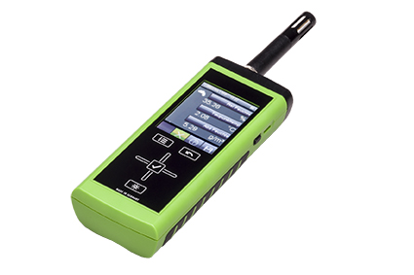
Figure 1: Multifunctional hand-held meter, Omniport 30, from E+E Elektronik.

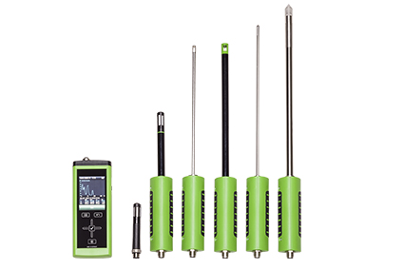
Figure 2: The wide range of E+E sensing probes allows for use in various applications.

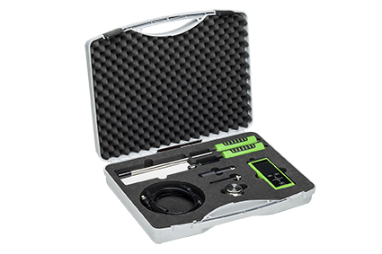
Figure 3: The Omniport 30 with sensing probes and accessories in the convenient carrying case.

Photos: E+E Elektronik GmbH, reprint free of charge

About E+E Elektronik:
E+E Elektronik GmbH, with headquaters in Engerwitzdorf/Austria, belongs to the Dr. Johannes Heidenhain GmbH group. With around 250 employees, E+E develops and manufactures sensors and transmitters for relative humidity, CO2, air velocity and flow as well as humidity calibration systems. The main E+E markets are HVAC, process control and automotive. With an export share of around 97 % E+E has branch offices in China, Germany, France, Italy, Korea and the USA as well as an international dealer network. Beside operating own accredited calibration laboratories, E+E Elektronik has been appointed by the Austrian Federal Office for Calibration and Measurement (Bundesamt für Eich- und Vermessungswesen; BEV) as designated laboratory to supply the national standards for humidity and air velocity.

Contact:
E+E Elektronik GmbH T: +43 (0) 7235 605-0
Langwiesen 7 F: +43 (0) 7235 605-8
A-4209 Engerwitzdorf info@epluse.at
Austria www.epluse.com

Marketing contact: Mr. Johannes Fraundorfer
Email: johannes.fraundorfer@epluse.at

