PRESS RELEASE
Austrian sensor specialist demonstrates innovation
E+E Elektronik with multiple product innovations at Sensor+Test 2014

(Engerwitzdorf, 3.6.2014) At this year's Sensor+Test, Austrian sensor specialist E+E Elektronik will be demonstrating their full innovative powers with a whole range of new products for industry, HVAC and OEM applications. The range of new developments includes sensors and transmitters for humidity, temperature, CO₂, flow, dew point and moisture in oil.

CO₂ sensor module for OEM applications
The CO₂ sensor module EE893 was developed especially for challenging OEM applications. Thanks to the measurement principle (NDIR dual wavelenght procedure) based on infrared technology, ageing effects are compensated automatically. The module is also particularly insensitive to environmental influences. The multiple point CO₂ and temperature adjustment ensures excellent measurement accuracy across the entire temperature working range. The CO₂ measurements with a measurement range up to 10,000 ppm are available on the digital E2 interface. Thanks to smaller dimensions and low power consumption, the module is also suitable for use in battery-operated devices such as wireless transmitters, hand-helds or data loggers.

CO₂ transmitter for challenging tasks
The advantages of the NDIR dual wavelength procedure are also brought to bear in the new CO₂ transmitters EE850 and EE820.
The CO₂ and temperature transmitter EE850 is ideal for use in building technology and applications in harsh environments. The CO₂ concentrations and temperature measurements are available on the analogue current or voltage outputs. As an option, the EE850 offers an additional passive temperature output.
The EE820 CO₂ transmitter was also developed for especially demanding applications. The robust, functional housing with integrated special filter allows the EE820 to be used in contaminated environments, such as in agricultural operations, stalls, hatchers or greenhouses.

Miniature humidity sensor of the next generation
With the new HC801, E+E Elektronik presents its smallest humidity sensor for mass applications to date. The miniature sensor for high precision humidity measurement is manufactured in thin layer technology based on silicon and is only 300 x 765 μm in size. Maximum reproducibility of the sensor characteristics and linearity across the entire humidity range, as with all humidity sensors in the HC series, further benefits the sensor element.

Flow sensor
The new VTQ is a thin layer sensor, combined with the latest transfer molding technology. The result is a compact, easy to assemble sensor element with high dirt resistance and outstanding reproducibility of the sensor characteristics. Other advantages of the sensor are the rapid response time, low angle dependence and a wider measurement range up to 20 m/s.

Temperature sensor series for the HVAC sector
The new E+E sensors are suitable for passive temperature measurement, primarily in HVAC and building technology. The product range includes a variety of models, such as a duct or immersion sensor (EE431). Also available are outdoor sensors (EE451), strap-on sensors (EE441), a cable sensor (EE461) or a model with remote probe (EE471).
An innovative production and mounting concept ensures a high protection class (IP65) and permits especially simple and rapid mounting of the sensors.
Compact dew point transmitter
The EE354 miniature transmitter permits precise dew point measurement and is ideal for monitoring refrigeration driers and use in OEM applications. The small design, robust stainless steel housing and excellent long-term stability are further advantages of the transmitter. The measurement values are issued on an analogue 4-20 mA and a digital Modbus RTU output.

Multi-functional hand-held meter with interchangeable sensing probes
A wide range of applications is offered by the multi-functional handheld unit Omniport 30. With various interchangeable sensing probes, up to 22 measurements can be recorded, such as relative humidity, temperature, air velocity and CO₂ and the data stored via the data logger function. Operation is simple and intuitive via the large touchscreen display.

Moisture in oil transmitter
Precise information on the moisture in oil can save costs for unnecessary maintenance work and avoid expensive machine downtimes. The EE364 transmitter provides the option of continuous monitoring of transformer, lubrication, hydraulic and engine oils as well as diesel fuel. The measurements for water activity (a_{w}), temperature (t) and water content (x) are output via two configurable 4-20 mA analogue outputs as well as a digital Modbus RTU interface. The compact design and the stainless steel housing permit space-saving integration in demanding applications.

Humidity/temperature transmitter for challenging environments
The EE210 permits precise humidity and temperature measurement, even in difficult environmental conditions. This is ensured via the combination of completely encapsulated measurement electronics and the special E+E coating on the HCT01 humidity sensor. The EE210 also calculates further physical values such as dew point temperature, absolute humidity and mixing ratio. The transmitter is available as a wall or duct version, with an optional display. A model with remote sensing probe was also recently launched. Typical applications for the EE210 are in agriculture (stalls, hatchers, incubators, greenhouses), in storage rooms, cooling chambers or indoor pools.

Characters: 4713 (excluding spaces)
Words: 801

Images:
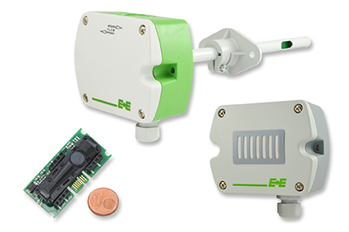  Figure 1: EE893 CO₂ sensor module and EE820, EE850 CO₂ transmitter. | 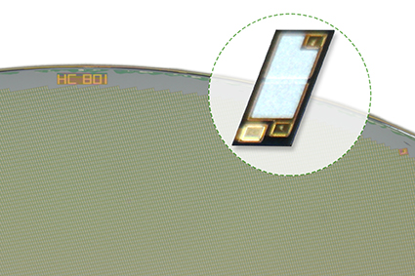  Figure 2: HC801 miniature humidity sensor for mass applications.
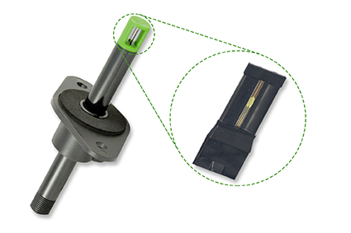  Figure 3: VTQ flow sensor. | 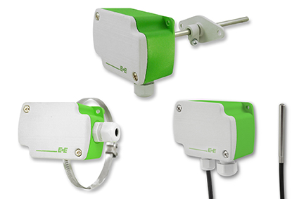  Figure 4: Temperature sensor series for HVAC.
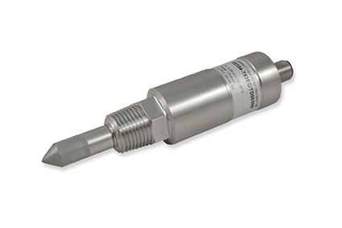  Figure 5: EE354 dew point transmitter. | 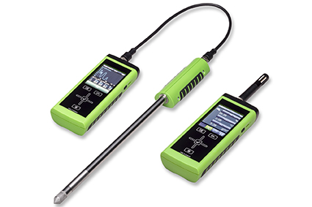  Figure 6: Omniport 30 hand-held meter with data logging.
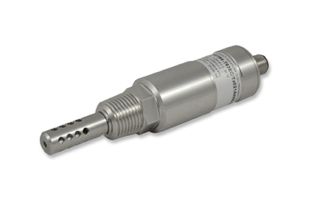  Figure 7: EE364 moisture in oil transmitter. | 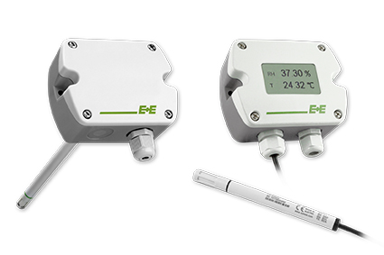  Figure 8: EE210 humidity / temperature transmitter.

Photos: E+E Elektronik GmbH, reprint free of charge

About E+E Elektronik:
E+E Elektronik GmbH, with headquaters in Engerwitzdorf/Austria, belongs to the Dr. Johannes Heidenhain GmbH group. With around 250 employees, E+E develops and manufactures sensors and transmitters for relative humidity, CO2, air velocity and flow as well as humidity calibration systems. The main E+E markets are HVAC, process control and automotive. With an export share of around 97 % E+E has branch offices in China, Germany, France, Italy, Korea and the USA as well as an international dealer network. Beside operating own accredited calibration laboratories, E+E Elektronik has been appointed by the Austrian Federal Office for Calibration and Measurement (Bundesamt für Eich- und Vermessungswesen; BEV) as designated laboratory to supply the national standards for humidity and air velocity.

Contact:
E+E Elektronik GmbH T: +43 (0) 7235 605-0
Langwiesen 7 F: +43 (0) 7235 605-8
A-4209 Engerwitzdorf info@epluse.at
Austria www.epluse.com

Marketing contact: Mr. Johannes Fraundorfer
Email: johannes.fraundorfer@epluse.at

