PRESS RELEASE
Calibration at the Highest Level
Calibration Certificates from E+E Elektronik Carry the CIPM MRA Logo

(Engerwitzdorf, 19.11.2015) E+E Elektronik maintains the national standards for humidity and air velocity in Austria as a designated laboratory of the Federal Office for Metrology, BEV (Bundesamt für Eich- und Vermessungswesen). Recently, the International Bureau of Weights and Measures (BIPM) authorized E+E Elektronik to use the CIPM MRA logo (International Committee for Weights and Measures - Mutual Recognition Arrangement) on its BEV/E+E calibration certificates.

Only National Metrological Institutes (NMI) and their designated laboratories, which are the highest metrological authorities of a country, are permitted to use the CIPM MRA logo. The prerequisite for this is that their Calibration and Measurement Capabilities (CMC) data is listed in the BIPM Key Comparison Database (KCDB). A certificate issued by a laboratory under the CIPM MRA is accepted by assessors from Conformity Assessment Bodies with the highest level of confidence.

As designated laboratory of the BEV, E+E Elektronik is an implicit cosignatory of the MRA. The E+E calibration laboratory undergoes regular audits by international experts, participates in international measurement comparisons and established a quality management system certified according to ISO 17025.

E+E Elektronik offers calibration services for humidity, dewpoint, air velocity, gas mass flow, temperature, CO₂ and pressure. Calibrations are carried out either in the designated laboratory (NMI) or the accredited OEKD calibration laboratory. Additionally, the E+E service department performs in-house or on-site ISO calibrations according to the E+E standard.

The website www.eplusecal.com provides an overview of all E+E calibration services including online calibration request.

Characters (no spaces): 1498
Words: 241

Images:
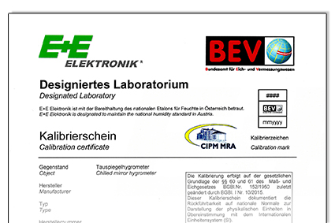

Figure 1: BEV/E+E calibration certificate with CIPM MRA logo.

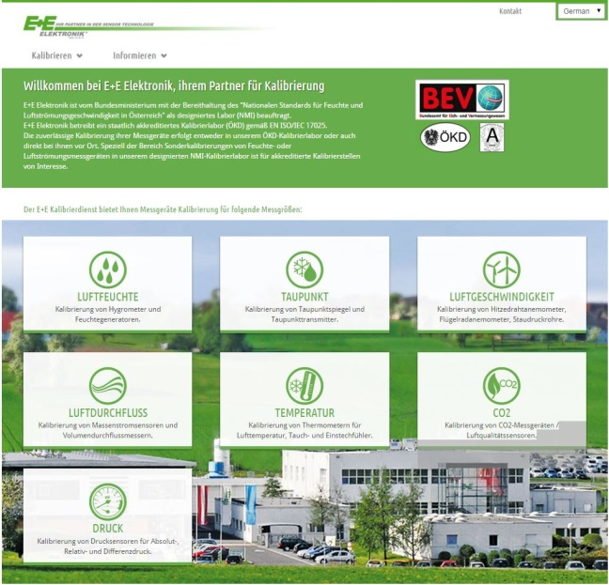
Figure 2: The website www.eplusecal.com provides information about all the calibration services offered by E+E Elektronik.

Photos: E+E Elektronik GmbH, reprint free of charge

About E+E Elektronik:
E+E Elektronik develops and manufactures sensors and transmitters for humidity, temperature, dewpoint, moisture in oil, air velocity, flow and CO₂. Data loggers, hand-held measuring devices and calibration systems complete the comprehensive product portfolio of the Austrian sensor specialist. The main applications for E+E products lie in HVAC, building automation, industrial process control and the automotive industry. A certified quality management system according to ISO 9001 and ISO/TS 16949 ensures the highest quality standards. E+E Elektronik has a worldwide dealership network and representative offices in Germany, France, Italy, Korea, China and the United States. The accredited E+E calibration laboratory (OEKD) has been commissioned by the Austrian Federal Office for Metrology (BEV)) to provide the national standards for humidity and air velocity.

Contact:
E+E Elektronik GmbH T: +43 (0) 7235 605-0
Langwiesen 7 F: +43 (0) 7235 605-8
A-4209 Engerwitzdorf info@epluse.at
Austria www.epluse.com

For further inquiries: Mr. Johannes Fraundorfer
Tel.: +43 (0)7235 605-217
Email: pr@epluse.at

