PRESS RELEASE
New "Compact Class" for HVAC and Building Technology
HVAC Humidity & Temperature Transmitter for Duct Mounting

(Engerwitzdorf, 23.02.2015) The new EE150 humidity & temperature transmitter has been optimized specifically for use in the HVAC and building technology sectors and impresses with an outstanding price/performance ratio. The clever housing concept, the compact design and the Ø 6mm probe simplify mounting of the transmitter, which results in minimized installation costs. The IP65/NEMA 4 enclosure provides optimal protection of the electronics and the capacitive E+E humidity sensor element guarantees long-term stable measurement results.

The EE150 features a particularly installation-friendly design. Thanks to the external mounting holes it is not necessary to open the housing for mounting. This means that the electronics are protected against construction site pollution. For duct mounting the RH/T probe of just 6mm in diameter does not require a hole any larger than a standard T probe. The mounting flange further simplifies installation of the transmitter. The benefits are shorter mounting times and thus minimized installation costs.

The PTFE filter cap protects the sensing head against contamination, ensuring excellent long-term stability. The measured values are issued via two 0-10V or 4-20mA analog outputs. Using an optional configuration kit and the free software, the user can set the output scaling and perform a 1 or 2 point adjustment for humidity and temperature.

Characters: 1281 (excluding spaces)
Words: 221

Images:
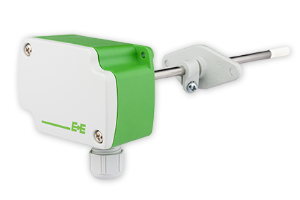
Figure 1: Compact humidity & temperature transmitter for HVAC and building technology from E+E Elektronik.

Photos: E+E Elektronik GmbH, reprint free of charge

About E+E Elektronik:
E+E Elektronik GmbH, with headquaters in Engerwitzdorf/Austria, belongs to the Dr. Johannes Heidenhain GmbH group. With over 250 employees, E+E develops and manufactures sensors and transmitters for relative humidity, CO₂, air velocity and flow as well as humidity calibration systems. The main E+E markets are HVAC, process control and automotive. With an export share of around 97% E+E has branch offices in China, Germany, France, Italy, Korea and the USA as well as an international dealer network. Aside from operating its own accredited calibration laboratories, E+E Elektronik has been appointed by the Austrian Federal Office for Calibration and Measurement (Bundesamt für Eich- und Vermessungswesen; BEV) as a designated laboratory to supply the national standards for humidity and air velocity.

Contact:
E+E Elektronik GmbH T: +43 (0) 7235 605-0
Langwiesen 7 F: +43 (0) 7235 605-8
A-4209 Engerwitzdorf info@epluse.at
Austria www.epluse.com

Marketing contact: Mr. Johannes Fraundorfer
Email: johannes.fraundorfer@epluse.at

