PRESS RELEASE

Safe Measurement in Gas and Dust Hazard Areas

The EE300Ex Humidity & Temperature Transmitter Conforms to International Standards for Intrinsically Safe Applications

(Engerwitzdorf, 21.01.2015) The intrinsically safe EE300Ex humidity & temperature transmitter from E+E Elektronik conforms to the European ATEX Directive and now also to the international IECEx and the FM classification specifically relevant to the USA and Canada. This makes the device suitable for worldwide usage in explosion hazard areas.

The EE300Ex was developed for use in explosion hazard environments and can be mounted directly in both gas and dust hazard areas of zone 0 / Div1. Precise humidity and temperature measurements from 0…100 %rel. hum. and -40…180 °C (-40...356 °F) are also possible in applications under pressure up to 300 bar (4351 psi). Just as with humidity measurement in air, the EE300Ex can also be used for moisture measurement in oils.

Various models of the EE300Ex offer a high degree of flexibility. As a compact variant – with or without display – the transmitter can be mounted directly in the hazard area. With a remote probe, temperature classifications up to T6 can also be achieved. Depending on requirements, an EE300Ex model for combined humidity and temperature measurement or for temperature measurement only is available.

The two-part stainless steel housing (separate connection area and measurement unit) simplifies installation of the transmitter considerably. It also permits the rapid replacement of the measurement unit – such as for calibration – without time-consuming re-cabling.

The measured values are issued on two analogue outputs with 4…20mA. The power can be supplied via any intrinsically safe power supply device. In addition to the measured values for humidity and temperature, dew point, frost point, absolute humidity, mixing ratio and other calculated values can also be issued.

The configuration software permits customised configuration of the transmitter outside the hazardous area and permits, flexible, simple and rapid adaptation of the analogue outputs for the relevant application.

Characters: 1802 (excluding spaces)
Words: 315

Images:
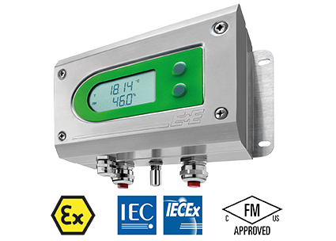

Figure 1: The EE300Ex humidity & temperature transmitter from E+E Elektronik conforms to international standards for intrinsically safe applications.

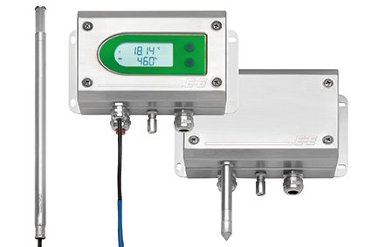

Figure 2: A variety of different models of the EE300Ex offer a high degree of flexibility in application.

Photos: E+E Elektronik GmbH, reprint free of charge

About E+E Elektronik:
E+E Elektronik GmbH, with headquaters in Engerwitzdorf/Austria, belongs to the Dr. Johannes Heidenhain GmbH group. With over 250 employees, E+E develops and manufactures sensors and transmitters for relative humidity, CO₂, air velocity and flow as well as humidity calibration systems. The main E+E markets are HVAC, process control and automotive. With an export share of around 97 % E+E has branch offices in China, Germany, France, Italy, Korea and the USA as well as an international dealer network. Aside from operating its own accredited calibration laboratories, E+E Elektronik has been appointed by the Austrian Federal Office for Calibration and Measurement (Bundesamt für Eich- und Vermessungswesen; BEV) as a designated laboratory to supply the national standards for humidity and air velocity.

Contact:
E+E Elektronik GmbH T: +43 (0) 7235 605-0
Langwiesen 7 F: +43 (0) 7235 605-8
A-4209 Engerwitzdorf info@epluse.at
Austria www.epluse.com

Marketing contact: Mr. Johannes Fraundorfer
Email: johannes.fraundorfer@epluse.at

