PRESS RELEASE
Highly Accurate Outdoor Measurement
Humidity and Temperature Transmitter for Demanding Meteorological Applications

(Engerwitzdorf, 12.10.2015) EE33-M is the newest addition to the well proven EE33 transmitter series for relative humidity (RH) and temperature (T). The heated RH sensor, the additional heating of the RH sensing probe and a separate T probe ensure highly accurate outdoor measurements even under condensation conditions. A special coating protects the RH sensor against pollution. Together with a radiation shield, EE33-M is ideal for high-end meteorology applications.

The heart of EE33-M is the innovative, monolithic HMC01 sensor, developed and manufactured in thin-film technology by E+E Elektronik. HMC01 combines the RH sensor and heating resistor on a single substrate. A dual heating system prevents condensation on the RH sensor, on the sensing probe and on the filter cap, which leads to extremely short response time and fast recovery after condensing conditions. The measuring principle with separate RH and T probes enables precise continuous measurement even at permanent high humidity. The proprietary E+E coating protects the RH sensor element and its leads against corrosive and electrically conductive pollution.

A radiation shield is essential for best performance outdoors. The sensing probes of EE33M match modern radiation shields with forced ventilation such as LAM630.

EE33-M calculates all RH and T related parameters such as dew point temperature, absolute humidity, and mixing ratio. An optional connection cable allows for easy adjustment and configuration of the transmitter. The optional RS485 interface enables a network of up to 32 transmitters.

Characters (no spaces): 1447
Words: 246

Images:

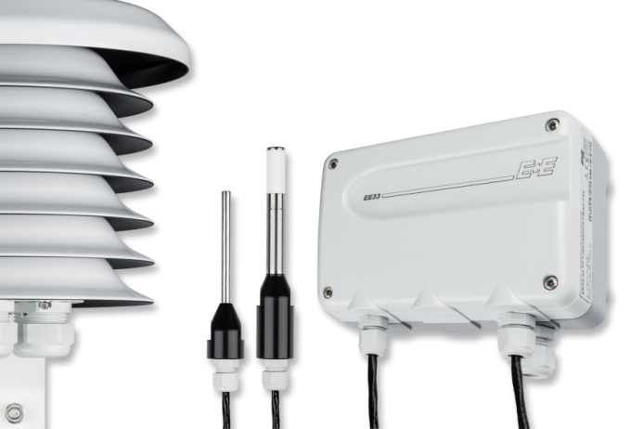

Figure 1: The new EE33-M humidity and temperature transmitter is ideal for demanding meteorological applications.

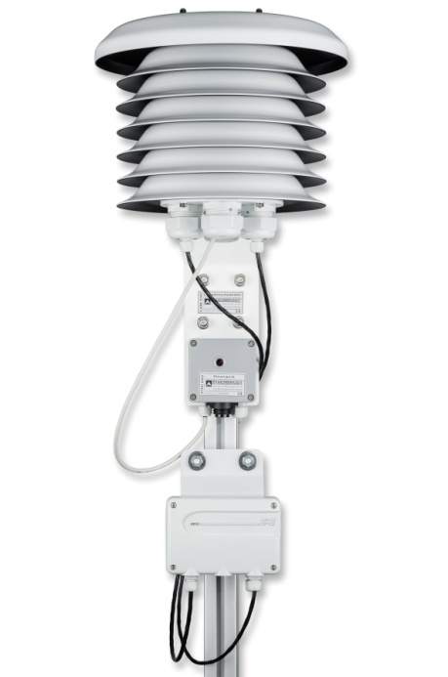
Figure 2: EE33-M humidity and temperature transmitter with radiation shield LAM630.

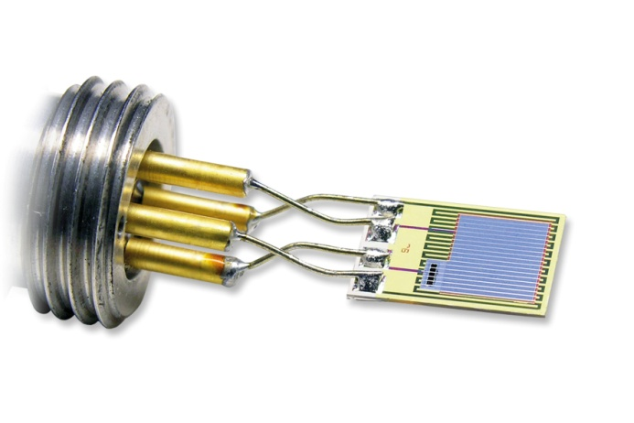
Figure 3: Core of the EE33-M is the heated, monolithic HMC01 RH/T sensor.

Photos: E+E Elektronik GmbH, reprint free of charge

About E+E Elektronik:
E+E Elektronik develops and manufactures sensors and transmitters for humidity, temperature, dewpoint, moisture in oil, air velocity, flow and CO₂. Data loggers, hand-held measuring devices and calibration systems complete the comprehensive product portfolio of the Austrian sensor specialist. The main applications for E+E products lie in HVAC, building automation, industrial process control and the automotive industry. A certified quality management system according to ISO 9001 and ISO/TS 16949 ensures the highest quality standards. E+E Elektronik has a worldwide dealership network and representative offices in Germany, France, Italy, Korea, China and the United States. The accredited E+E calibration laboratory (ÖKD) has been commissioned by the Austrian Federal Office for Metrology (BEV)) to provide the national standards for humidity and air velocity.

Contact:
E+E Elektronik GmbH T: +43 (0) 7235 605-0
Langwiesen 7 F: +43 (0) 7235 605-8
A-4209 Engerwitzdorf info@epluse.at
Austria www.epluse.com

For further inquiries: Mr. Johannes Fraundorfer
Tel.: +43 (0)7235 605-217
Email: pr@epluse.at

