PRESS RELEASE
Accurate Dewpoint Measurement down to -60°C Td
Compact Dewpoint Transmitter for OEM Applications

(Engerwitzdorf, 6.5.2015) The compact EE355 dewpoint transmitter measures dewpoint temperature with ±2°C accuracy across the entire working range. The unit offers an optimal price-performance ratio for OEM applications in compressed air systems, plastic dryers and other industrial drying processes.

With the new EE355, E+E Elektronik expanded its range of dewpoint products with a transmitter for the range -60…+60°C Td at an operating pressure up to 20 bar. Same as other E+E dewpoint transmitters, the EE355 features a special auto-calibration procedure which leads to ±2°C Td accuracy, and employs E+E polymer humidity sensors, which are condensation resistant and highly long-term stable.

The measured values for dewpoint, frost point or ppm volume concentration are available on the analog 4…20mA and on the digital Modbus RTU outputs. Integration into the measurement task is simplified considerably by the compact design and the robust stainless steel enclosure.

With the free configuration software and the optional Modbus to USB converter the user can scale the analog output, set up the Modbus communication and adjust the transmitter.

E+E Elektronik manufactures various models of dewpoint measuring instruments, from compact OEM transmitters to high-end devices for demanding process control, and covers with these a wide range of applications.

Characters (no spaces): 1244
Words: 212

Images:

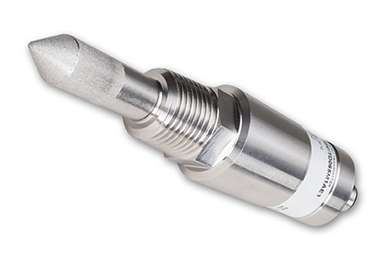
Figure 1: Compact EE355 dewpoint transmitter for OEM applications.

Photos: E+E Elektronik GmbH, reprint free of charge

About E+E Elektronik:
E+E Elektronik develops and manufactures sensors and transmitters for humidity, temperature, dewpoint, moisture in oil, air velocity, flow and CO₂. Dataloggers, hand-held transmitters and calibration systems complete the comprehensive product portfolio of the Austrian sensor specialist. The main applications for E+E products lie in HVAC building technology, industrial measurement technology and the automotive industry. A certified quality management system according to ISO 9001 and ISO/TS 16949 ensures the highest quality standards. E+E Elektronik manages a worldwide sales network and has representative offices in Germany, France, Italy, Korea, China and the United States. The accredited E+E calibration laboratory (ÖKD) has been commissioned by the Austrian Federal Office for Metrology (BEV)) to provide the national standards for humidity and air velocity.

Contact:
E+E Elektronik GmbH T: +43 (0) 7235 605-0
Langwiesen 7 F: +43 (0) 7235 605-8
A-4209 Engerwitzdorf info@epluse.at
Austria www.epluse.com

For further inquiries: Mr. Johannes Fraundorfer
Tel.: +43 (0)7235 605-217
Email: pr@epluse.at

