PRESS RELEASE
Compact Housing, High Protection Class, Easy Mounting
New Temperature Sensor Series for HVAC and Building Technology

(Engerwitzdorf, 10.03.2015) E+E Elektronik expands its product range with various sensors for passive temperature measurement for HVAC and building technology. The compact, innovative enclosure with protection class IP65/NEMA 4 facilitates easy and fast installation of the sensors. Due to external mounting holes the sensors can be installed with closed housing, which protects the device from building site contamination. The new temperature sensors line matches the design of the successful E+E humidity, CO₂ and air velocity sensors. The result is a comprehensive HVAC sensor choice, with a uniform look, from a single manufacturer.

EE431 duct / immersion temperature sensor
The EE431 duct sensor is ideal for the measurement of air temperature in heating, ventilation and air conditioning systems. In air ducts the sensor can be installed with the mounting flange and easily accessible inclined fixing screw. For measurement in liquids the sensors are mounted with an immersion well with innovative fixing clamp.

EE441 strap-on temperature sensor
The EE441 strap-on sensor can be fixed with a hose clamp onto ducts and pipes. Typical applications include heating systems (hot and cold water pipes) and solar collectors. The aluminium contact surface ensures very good heat transfer and a fast response time.

EE451 wall-mounted temperature sensor for indoor and outdoor
The EE451 can be used both indoors and outdoors for weather-dependent temperature control of heating, ventilation and air conditioning systems. A mounting bracket keeps the sensor at a distance from the wall, minimizing the wall temperature influence on the measurement of the air temperature.

EE461 cable temperature sensor
The EE461 cable temperature sensor is available with 0.5m to 3m cable length. The innovative star pressing of the sensor sleeve ensures IP65/NEMA 4 protection class. All product-specific information is printed on the cable. For temperature measurement in fluids the EE461 can be used with an immersion well.

EE471 temperature sensor with remote probe
The EE471 is available with various cable lengths between the sensing probe and housing. It can be used for measurement in the air as well as, with an immersion well, in liquids. Both the probe and the enclosure are IP65/ NEMA 4 rated.

Characters (no spaces): 2037
Words: 366

Images:

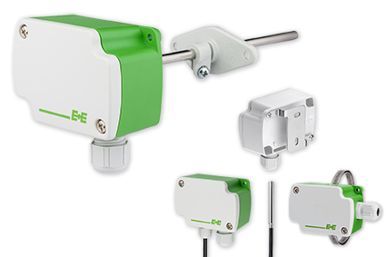
Figure 1: Passive temperature sensors for HVAC and building technology from E+E Elektronik.

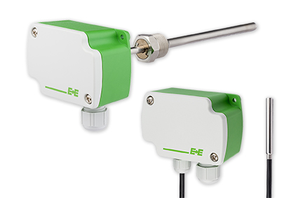
Figure 2: EE431 duct sensor with immersion well (left) and EE471 with remote sensing probe (right).

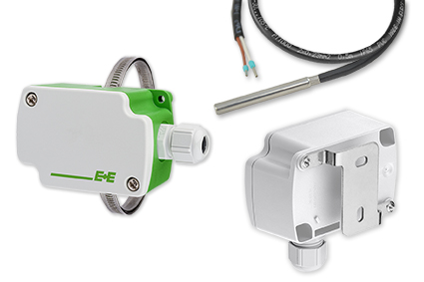
Figure 3: EE441 strap-on sensor (left), EE461 cable sensor (top right) and EE451 temperature sensor for wall mounting (bottom right).

Photos: E+E Elektronik GmbH, reprint free of charge

About E+E Elektronik:
E+E Elektronik GmbH, with headquaters in Engerwitzdorf/Austria, belongs to the Dr. Johannes Heidenhain GmbH group. With over 250 employees, E+E develops and manufactures sensors and transmitters for relative humidity, CO₂, air velocity and flow as well as humidity calibration systems. The main E+E markets are HVAC, process control and automotive. With an export share of around 97% E+E has branch offices in China, Germany, France, Italy, Korea and the USA as well as an international dealer network. Aside from operating its own accredited calibration laboratories, E+E Elektronik has been appointed by the Austrian Federal Office for Calibration and Measurement (Bundesamt für Eich- und Vermessungswesen; BEV) as a designated laboratory to supply the national standards for humidity and air velocity.

Contact:
E+E Elektronik GmbH T: +43 (0) 7235 605-0
Langwiesen 7 F: +43 (0) 7235 605-8
A-4209 Engerwitzdorf info@epluse.at
Austria www.epluse.com

Marketing contact: Mr. Johannes Fraundorfer
Email: johannes.fraundorfer@epluse.at

