PRESS RELEASE
Comprehensive Product Range for Temperature Measurement
Active Temperature Sensors for HVAC and Building Technology

(Engerwitzdorf, 3.6.2015) The new temperature sensors from E+E Elektronik are now also available with 0-10 V or 4-20 mA outputs. The active sensors extend the portfolio of the Austrian sensor specialist in the field of HVAC and building technology. The compact, innovative housing and mounting concept with protection class IP65 / NEMA 4 facilitates extremely simple and fast installation of the sensors.

The E+E temperature sensor range includes duct mounted types, sensors for wall mounting indoors and outdoors, a strap-on sensor for mounting on ducts and pipes, and a version with remote probe. Special immersion wells with innovative mounting spring turn the duct versions into immersion sensors for temperature measurement in fluids.

The sensors offer outstanding accuracy and a wide temperature range. The measured values are available at a 0-10 V or 4-20 mA output. The factory scaling is freely selectable and can be subsequently changed by the user by means of an optional configuration kit and free configuration software.

The clever housing design offers a considerable advantage when it comes to installing the sensor. Thanks to the external fixing holes, the device can be mounted with closed cover, which keeps the electronics protected against construction site pollution.

The new temperature sensor series from E+E Elektronik rounds off their existing product range of transmitters for humidity, CO₂ and air velocity, thereby offering an extensive sensor package for HVAC and building technology.

Characters (no spaces): 1385
Words: 245

Images:
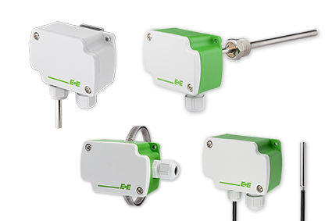

Figure 1: The E+E temperature sensors are available with analog (0-10 V or 4-20 mA) or passive outputs.

Photos: E+E Elektronik GmbH, reprint free of charge

About E+E Elektronik:
E+E Elektronik develops and manufactures sensors and transmitters for humidity, temperature, dewpoint, moisture in oil, air velocity, flow and CO₂. Data loggers, hand-held measuring devices and calibration systems complete the comprehensive product portfolio of the Austrian sensor specialist. The main applications for E+E products lie in HVAC, building automation, industrial process control and the automotive industry. A certified quality management system according to ISO 9001 and ISO/TS 16949 ensures the highest quality standards. E+E Elektronik has a worldwide dealership network and representative offices in Germany, France, Italy, Korea, China and the United States. The accredited E+E calibration laboratory (ÖKD) has been commissioned by the Austrian Federal Office for Metrology (BEV)) to provide the national standards for humidity and air velocity.

Contact:
E+E Elektronik GmbH T: +43 (0) 7235 605-0
Langwiesen 7 F: +43 (0) 7235 605-8
A-4209 Engerwitzdorf info@epluse.at
Austria www.epluse.com

For further inquiries: Mr. Johannes Fraundorfer
Tel.: +43 (0)7235 605-217
Email: pr@epluse.at

