PRESS RELEASE
High measurement accuracy down to 0.15 m/s
Transmitter for Very Low Air Velocity

(Engerwitzdorf, 2.4.2015) The new EE660 air velocity transmitter from E+E Elektronik measures air velocity down to 0.15 m/s and is particularly suitable for laminar flow control and other clean room applications. The E+E thin film sensor used in EE660 operates on the hot film anemometer principle which is characterized by high accuracy, excellent long-term stability and lowest sensitivity to dirt. The low angular dependence additionally simplifies installation of the transmitter.

The air velocity transmitter is available for wall or duct mounting as well as with remote probe. The large, flush-mounted LCD display with backlight is 180° rotatable and ensures optimal readability of the measured data.

The EE660 has a current and voltage output, whereby both signals are available on the terminal. The measurement range and the response time can be selected via jumpers. An optional kit facilitates easy adjustment of the transmitter and configuration of the display.

External mounting holes allow quick and easy installation of the transmitter with closed cover. This keeps the electronics protected from construction site pollution. In addition, the electronic components are located on the underside of the PCB and are thus safe from mechanical damage during installation.

Characters (no spaces): 1157
Words: 205

Images:

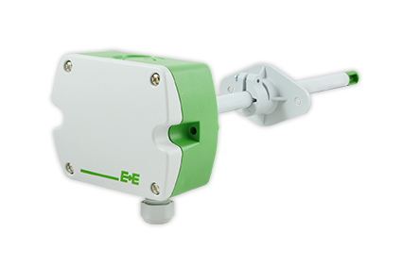
Figure 1: Highly accurate EE660 air velocity transmitter for duct mounting.

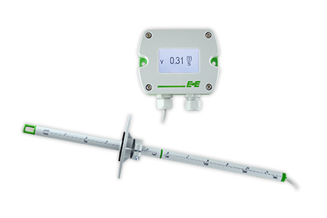
Figure 2: EE660 air velocity transmitter with display and remote probe.

Photos: E+E Elektronik GmbH, reprint free of charge

About E+E Elektronik:
E+E Elektronik GmbH, with headquaters in Engerwitzdorf/Austria, belongs to the Dr. Johannes Heidenhain GmbH group. With over 250 employees, E+E develops and manufactures sensors and transmitters for relative humidity, CO₂, air velocity and flow as well as humidity calibration systems. The main E+E markets are HVAC, process control and automotive. With an export share of around 97% E+E has branch offices in China, Germany, France, Italy, Korea and the USA as well as an international dealer network. Aside from operating its own accredited calibration laboratories, E+E Elektronik has been appointed by the Austrian Federal Office for Calibration and Measurement (Bundesamt für Eich- und Vermessungswesen; BEV) as a designated laboratory to supply the national standards for humidity and air velocity.

Contact:
E+E Elektronik GmbH T: +43 (0) 7235 605-0
Langwiesen 7 F: +43 (0) 7235 605-8
A-4209 Engerwitzdorf info@epluse.at
Austria www.epluse.com

Marketing contact: Mr. Johannes Fraundorfer
Email: johannes.fraundorfer@epluse.at

