PRESS RELEASE
Smart Solution for Indoor Climate Control
Room Transmitter for CO₂, Humidity and Temperature

(Engerwitzdorf, 13.08.2015) The EE800 transmitter from E+E Elektronik measures CO₂, temperature and relative humidity and calculates the dew point temperature. The versions with Modbus RTU or BACnet MS/TP interface also calculate absolute humidity, mixing ratio, specific enthalpy, frost point temperature and partial water vapour pressure. In addition, they can be easily integrated into a bus system for building automation or automatic indoor climate control.

The CO₂ infrared measuring principle (dual wavelength NDIR*) used on the EE800 is characterized by high resistance to contamination. The auto-calibration compensates for ageing effects, which leads to exceptional long-term stability. A multi-point CO₂ and temperature factory adjustment ensures excellent CO₂ measurement accuracy across the entire temperature working range.

The EE800 versions with analogue output (current or voltage) also feature also an optional passive temperature output.

The innovative snap-on design allows for fast mounting and minimizes installation costs. In order to meet various international standards the EE800 is available in two enclosure sizes. The measured or calculated values can be read on the optional display. An optional USB configuration adapter facilitates easy setup and adjustment of the EE800.

*non-dispersive infrared technology

Characters (no spaces): 1234
Words: 198

Images:

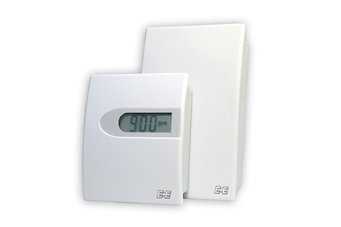
Figure 1: EE800 room transmitter for CO₂, humidity and temperature.

Photos: E+E Elektronik GmbH, reprint free of charge

About E+E Elektronik:
E+E Elektronik develops and manufactures sensors and transmitters for humidity, temperature, dewpoint, moisture in oil, air velocity, flow and CO₂. Data loggers, hand-held measuring devices and calibration systems complete the comprehensive product portfolio of the Austrian sensor specialist. The main applications for E+E products lie in HVAC, building automation, industrial process control and the automotive industry. A certified quality management system according to ISO 9001 and ISO/TS 16949 ensures the highest quality standards. E+E Elektronik has a worldwide dealership network and representative offices in Germany, France, Italy, Korea, China and the United States. The accredited E+E calibration laboratory (ÖKD) has been commissioned by the Austrian Federal Office for Metrology (BEV)) to provide the national standards for humidity and air velocity.

Contact:
E+E Elektronik GmbH T: +43 (0) 7235 605-0
Langwiesen 7 F: +43 (0) 7235 605-8
A-4209 Engerwitzdorf info@epluse.at
Austria www.epluse.com

For further inquiries: Mr. Johannes Fraundorfer
Tel.: +43 (0)7235 605-217
Email: pr@epluse.at

