Successfully Accredited
E+E Elektronik Offers Accredited Calibrations for CO₂

(Engerwitzdorf, 18.02.2016) The Austrian sensor specialist E+E Elektronik offers now accredited calibrations also for CO₂-fraction in gas. The E+E calibration laboratory is accredited by Akkreditierung Austria according to DIN EN ISO/IEC 17025 and is the only facility in Austria which can carry out CO₂ calibrations at this high level.

The E+E calibration laboratory offers accredited CO₂ calibrations for gas concentrations in the range 5 … 300,000 ppm (μmol/mol), as well as for the equivalent volume fraction in μL/L. Due to the wide calibration range it is possible to calibrate all common CO₂ measuring devices such as sensors, handhelds, data loggers and spectrometers.

The calibration is performed as comparative measurement with a constant CO₂ reference concentration. The CO₂ reference concentration is generated by a special gas mixing pump according to DIN 51898-1 and is freely selectable. The piston pump works with four high-precision pistons. The gas volume flow is precisely defined by the diameter of the cylinder, the stroke and the frequency, and can therefore be traced back to length, which is a fundamental physical quantity of the International System of Units (SI).

According to the International Laboratory Accreditation Cooperation (ILAC) agreements, only calibration laboratories accredited according to EN ISO/IEC 17025 can ensure the traceability of measurement results to SI and full international comparability. The accredited calibration certificate states the measurement uncertainty associated to the specific calibration process.

Accredited CO₂ calibration certificates are generally required for measuring devices used for safety or for the control of key manufacturing processes. Accredited CO₂ calibrations are of interest for instance in the Food and Drugs Administration (FDA) regulated industries such as food and pharmaceutical. Reliable CO₂ monitoring and control is paramount for biological incubators. In building automation, the accuracy of CO₂ measuring devices impacts directly on the efficiency of demand controlled ventilation systems.

In addition to CO₂, the calibration laboratory of E+E Elektronik GmbH is accredited for humidity, dew point, temperature, pressure, air velocity and mass flow by Akkreditierung Austria / Federal Ministry of Science, Research and Economy according to DIN EN ISO/IEC 17025 with identification number 0608.

Details on the E+E scope of accreditation and calibration services are available at www.eplusecal.com.

Characters (no spaces): 2205
Words: 367

Images
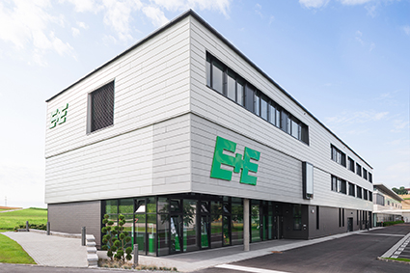 | Figure 1: The Austrian sensor specialist E+E Elektronik offers now accredited calibrations for CO₂.
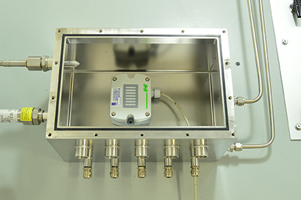 | Figure 2: The devices under calibration are placed in a chamber with precisely defined gas concentration.

Photos: E+E Elektronik Ges.m.b.H., reprint free of charge

About E+E Elektronik:
E+E Elektronik develops and manufactures sensors and transmitters for humidity, temperature, dew point, moisture in oil, air velocity, flow and CO₂. Data loggers, hand-held measuring devices and calibration systems complete the comprehensive product portfolio of the Austrian sensor specialist. The main applications for E+E products lie in HVAC, building automation, industrial process control and the automotive industry. A certified quality management system according to ISO 9001 and ISO/TS 16949 ensures the highest quality standards. E+E Elektronik has a worldwide dealership network and representative offices in Germany, France, Italy, Korea, China and the United States. The accredited E+E calibration laboratory (OEKD) has been commissioned by the Austrian Federal Office for Metrology (BEV)) to provide the national standards for humidity and air velocity.

Contact: www.epluse.com, info@epluse.at, T: +43 (0) 7235 605-0, F: +43 (0) 7235 605-8

For further inquiries: Mr. Johannes Fraundorfer, T: +43 (0)7235 605-217, pr@epluse.at

