Humidity and Temperature Transmitter with Heated Sensing Probe
Improved Long-Term Stability in High-Humidity Conditions

(Engerwitzdorf, 3.11.2016) Continuous high relative humidity (RH) can impair the long-term stability and accuracy of humidity sensors. Therefore, the new EE211 humidity transmitter from the Austrian sensor specialist E+E Elektronik features a heated sensing probe. This leads to best accuracy and long-term stability in high-humidity (>85% RH) and even in condensing environment.

The EE211 is designed for accurate humidity and temperature measurement under continuous high-humidity or condensing conditions. The device is ideal for climate control in fruit and vegetable storage, in greenhouses, incubators, ripening processes or in mushroom growing.

Heated humidity probe
In order to avoid drift effects due to long-term exposure of the sensing elements to high humidity, the sensor head of the EE211 humidity probe is continuously heated. The permanent over-temperature leads to max. 80% RH at the sensor. Condensation-related dirt deposits as well as corrosion of the sensor are thereby prevented.
Furthermore, the unique E+E protective coating also protects the active sensor surface from contamination and corrosive influences.
The combination of these features results in considerably improved long-term stability and increases both the service life and the measuring performance of the sensor.

Measured values and interfaces
The EE211 calculates the dew point temperature (Td) based on the RH and temperature values measured by the heated humidity probe. A separate, interchangeable temperature probe measures the ambient temperature (T). From Td and T the EE211 calculates back the ambient relative humidity as well as additional physical quantities like absolute humidity, mixing ratio, wet-bulb temperature or specific enthalpy.

The measured values are available on the Modbus RTU interface or on two analogue current or voltage outputs. The optional backlit display can show up to three measurands simultaneously.

Easy configuration and adjustment
The Modbus RTU parameters, the scaling of the analogue outputs and the display layout can be set with the free configuration software. The user can also carry out one or two-point humidity and temperature adjustment. The temperature probe can also be calibrated separately.

Optimally protected electronics
The IP65/NEMA 4 enclosure offers optimal protection for the EE211 electronics. Additionally, for best performance even in aggressive environment, the measuring electronics inside the humidity probe are fully encapsulated.

Characters (no spaces): 2238
Words: 370

Images
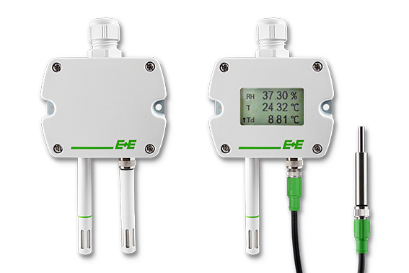

Figure 1: EE211 Humidity and temperature transmitter with heated sensing probe.

Photos: E+E Elektronik GmbH, reprint free of charge

About E+E Elektronik:
E+E Elektronik develops and manufactures sensors and transmitters for humidity, temperature, dewpoint, moisture in oil, air velocity, flow and CO₂. Data loggers, hand-held measuring devices and calibration systems complete the comprehensive product portfolio of the Austrian sensor specialist. The main applications for E+E products lie in HVAC, building automation, industrial process control and the automotive industry. A certified quality management system according to ISO 9001 and ISO/TS 16949 ensures the highest quality standards. E+E Elektronik has a worldwide dealership network and representative offices in Germany, France, Italy, Korea, China and the United States. The accredited E+E calibration laboratory (OEKD) has been commissioned by the Austrian Federal Office for Metrology (BEV) to provide the national standards for humidity and air velocity.

Contact: www.epluse.com, info@epluse.at, T: +43 (0) 7235 605-0, F: +43 (0) 7235 605-8

For further inquiries: Mr. Johannes Fraundorfer, T: +43 (0)7235 605-217, pr@epluse.at

