Accurate Control of Ventilation and Air Conditioning Systems
Air Velocity Transmitter for HVAC

(Engerwitzdorf, 9.3.2016) The EE650 air velocity transmitter from E+E Elektronik is optimized for accurate, reliable and long-term stable measurement of air velocity in ventilation ducts. With selectable measuring ranges 0-10/15/20 m/s (0-2000/3000/4000 ft/min) and high accuracy, the EE650 suits perfectly all common HVAC applications. The new E+E VTQ flow sensor element of EE650 operates on the thermal anemometer principle, is very robust and highly insensitive to pollution.

Thanks to the design and the innovative flow profile of the VTQ flow sensor element manufactured by E+E in thin-film technology, EE650 features an outstanding resistance to contamination. The sensor element impresses also with high mechanical stability realized through state-of-the-art transfer-moulding technology. The exceptional long-term stability and the wear-free thermal measuring principle minimize the EE650 maintenance demand and ownership costs.

The IP65 / NEMA 4 enclosure protects optimally the electronics against pollution. Due to its design, the EE650 can be very easily installed and commissioned. The mounting flange facilitates precise positioning of the probe in the air stream. The duct version can be also mounted directly onto the ventilation duct. With the remote probe version, the sensing probe can be installed up to 10 m away from the electronics.

The measuring range, the output signal (4-20 mA or 0-10 V) and the response time can be selected with jumpers on the electronics board. The maintenance is considerably simplified by a digital interface which allows for EE650 to be adjusted by the user.

Characters (no spaces): 1453
Words: 252

Images
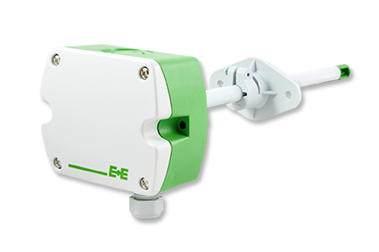 | Figure 1: EE650 duct mount air velocity transmitter.
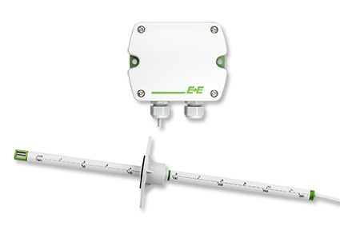 | Figure 2: EE650 air velocity transmitter with remote probe.

Photos: E+E Elektronik Ges.m.b.H., reprint free of charge

About E+E Elektronik:
E+E Elektronik develops and manufactures sensors and transmitters for humidity, temperature, dewpoint, moisture in oil, air velocity, flow and CO₂. Data loggers, hand-held measuring devices and calibration systems complete the comprehensive product portfolio of the Austrian sensor specialist. The main applications for E+E products lie in HVAC, building automation, industrial process control and the automotive industry. A certified quality management system according to ISO 9001 and ISO/TS 16949 ensures the highest quality standards. E+E Elektronik has a worldwide dealership network and representative offices in Germany, France, Italy, Korea, China and the United States. The accredited E+E calibration laboratory (ÖKD) has been commissioned by the Austrian Federal Office for Metrology (BEV)) to provide the national standards for humidity and air velocity.

Contact: www.epluse.com, info@epluse.at, T: +43 (0) 7235 605-0, F: +43 (0) 7235 605-8

For further inquiries: Mr. Johannes Fraundorfer, T: +43 (0)7235 605-217, pr@epluse.at

