Suitable for Various Pipe Diameters
Modular In-Line Flow Meter for Compressed Air and Gases

(Engerwitzdorf, 14.09.2016) The compact EE741 in-line flow meter from E+E Elektronik measures accurately the consumption of compressed air and technical gases. Thanks to the modular design, one and the same transmitter can be used for three different pipe diameters (DN15, DN20, DN25). To do so, the transmitter is simply combined with the appropriate gauge mounting block. The thermal hot-film anemometer measurement principle stands for best long-term stability and short response time.

Easy installation and low maintenance make the EE741 ideal for cost-effective consumption measurement of compressed air and technical gases such as nitrogen, oxygen, helium, CO₂ or argon. The flow meter can accurately monitor standard volume flow, mass flow, standard flow, temperature as well as the consumption of air or gas.

In combination with the corresponding gauge mounting block the transmitter can be employed for pipe diameters DN15, DN20 or DN25. The gauge mounting block is permanently mounted at an appropriate location of the pipeline. The transmitter, with its robust stainless steel sensing head can be installed and removed without disassembling the pipework and with only a short interruption of the air or gas flow. The gauge mounting block features a sealing plug for operation without transmitter. This construction facilitates the periodical calibration of the transmitter and its temporary use at several measuring points.

The EE741 employs the well proven E+E thin-film sensor, which operates on the thermal anemometer principle and stands out by excellent long-term stability and short response time. The thin-film sensor is highly insensitive to contamination and the operation principle eliminates the need for additional pressure or temperature compensation. The multi-point factory adjustment at 7 bar (102 psi), which is the common pressure of the compressed air supply, leads to best accuracy even in the lower measuring range. By this, EE741 can be optimally employed for leak detection.

The instantaneous measured values or the total consumption can be displayed on the optional state-of-the-art display. For optimum readability independent from the transmitter location, the display can be rotated in 90° increments. All the settings for commissioning can be performed with the push buttons and the display. The EE741 versions without display can be configured via USB interface with the free EE-PCS product configuration software.

One particularly useful feature of the EE741 is the integrated consumption meter which enables cost-effective consumption monitoring without an additional datalogger.

The EE741 flow meter can be easily integrated in any measurement and monitoring chain. It features a scalable analogue output (4-20 mA / 0-20 mA), two switch outputs and a pulse output. A Modbus RTU or M-Bus (Meter-Bus) interface makes the device future-proof and ready for Industry 4.0.

Characters (no spaces): 2553
Words: 449

Images

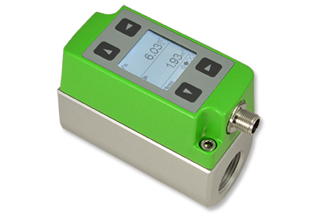 | Figure 1: Compact EE741 in-line flow meter.
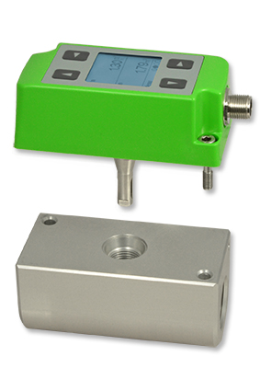 | Figure 2: Thanks to the modular design, the EE741 is suitable for three different pipe diameters.

Photos: E+E Elektronik GmbH, reprint free of charge

About E+E Elektronik:
E+E Elektronik develops and manufactures sensors and transmitters for humidity, temperature, dewpoint, moisture in oil, air velocity, flow and CO₂. Data loggers, hand-held measuring devices and calibration systems complete the comprehensive product portfolio of the Austrian sensor specialist. The main applications for E+E products lie in HVAC, building automation, industrial process control and the automotive industry. A certified quality management system according to ISO 9001 and ISO/TS 16949 ensures the highest quality standards. E+E Elektronik has a worldwide dealership network and representative offices in Germany, France, Italy, Korea, China and the United States. The accredited E+E calibration laboratory (OEKD) has been commissioned by the Austrian Federal Office for Metrology (BEV)) to provide the national standards for humidity and air velocity.

Contact: www.epluse.com, info@epluse.at, T: +43 (0) 7235 605-0, F: +43 (0) 7235 605-8

For further inquiries: Mr. Johannes Fraundorfer, T: +43 (0)7235 605-217, pr@epluse.at

