CO₂, T and RH room transmitter with new housing colours
The EE800 room transmitter for CO₂, temperature and relative humidity is now also available in "anthracite grey" and "white aluminum".

(Engerwitzdorf, 1.12.2016) The EE800 room transmitter from E+E Elektronik combines CO₂, temperature (T) and relative humidity (RH) measurement in a single device. It is ideal for use in demand-controlled ventilation and indoor climate control. In addition to the standard housing colour “signal white”, the EE800 is now also available in "anthracite grey" and "white aluminum", which are the most common colours of light switches and power sockets.

Besides modern design and new housing colours, the EE800 impresses by its technical features. The dual wavelength NDIR CO₂ measuring principle with auto-calibration is highly insensitive to contamination, compensates for ageing effects and leads to outstanding long-term stability. Additionally, the multi-point CO₂ and temperature factory adjustment ensures excellent CO₂ measurement accuracy across the entire temperature working range.

Out of the RH and T measured values, EE800 calculates the dew point temperature. The versions with Modbus RTU or BACnet MS/TP interface calculate also further physical quantities, such as absolute humidity, mixing ratio or specific enthalpy. The digital interfaces allow for easy integration into a modern bus system for building automation.
The EE800 versions with analogue outputs (current or voltage) also feature an optional passive temperature output.
An optional USB configuration adapter facilitates easy setup and adjustment of the device.

Further room transmitters
In addition to the EE800, the E+E portfolio also includes room transmitters for combined RH and T measurement (EE10), T measurement only (EE10-T) and a CO₂ switch (EE80).

All E+E room transmitters are available in the new colours and with optional display. The innovative snap-on enclosure facilitates mounting of the device, which saves time and minimizes installation costs. The enclosure is available in two sizes corresponding to the EU and US standards.

Characters (no spaces): 1802
Words: 310
Images
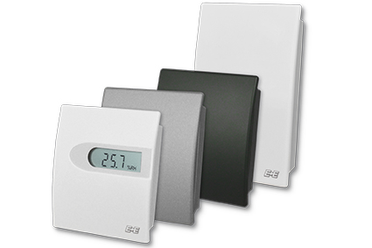

Figure 1: EE800 room transmitters from E+E Elektronik.

Photos: E+E Elektronik GmbH, reprint free of charge

About E+E Elektronik:
E+E Elektronik develops and manufactures sensors and transmitters for humidity, temperature, dewpoint, moisture in oil, air velocity, flow and CO₂. Data loggers, hand-held measuring devices and calibration systems complete the comprehensive product portfolio of the Austrian sensor specialist. The main applications for E+E products lie in HVAC, building automation, industrial process control and the automotive industry. A certified quality management system according to ISO 9001 and ISO/TS 16949 ensures the highest quality standards. E+E Elektronik has a worldwide dealership network and representative offices in Germany, France, Italy, Korea, China and the United States. The accredited E+E calibration laboratory (OEKD) has been commissioned by the Austrian Federal Office for Metrology (BEV) to provide the national standards for humidity and air velocity.

Contact: www.epluse.com, info@epluse.at, T: +43 (0) 7235 605-0, F: +43 (0) 7235 605-8

For further inquiries: Mr. Johannes Fraundorfer, T: +43 (0)7235 605-217, pr@epluse.at

