Extended Measuring Range
Modular CO₂ Transmitter Now Measures CO₂ Concentration up to 50,000 ppm

(Engerwitzdorf, 12.05.2016) The modular CO₂ transmitter EE870 from E+E Elektronik now measures CO₂ concentration up to 5 % CO₂ (50,000 ppm). The extended measuring range makes the EE870, consisting of CO₂ probe, conversion board and connection cable, even more versatile. The interchangeable CO₂ probe EE871 with auto-calibration uses an infrared measuring principle (dual wavelength NDIR operation principle) that is particularly insensitive to pollution. Aging effects are compensated automatically, resulting in excellent long-term stability. Thus the CO₂ transmitter is ideal for demanding applications.

The multi-point CO₂ and temperature adjustment ensures high accuracy over the entire temperature working range of -40...60 °C (-40...140 °F). Additionally, the IP65 probe enclosure with interchangeable PTFE filter offers excellent protection against pollution. Therefore, the CO₂ probe can be used in harsh environments such as in agriculture (stables, hatchers, incubators).

The compact design, the M12 connector and the optional mounting flange allow for fast installation or replacement of the CO₂ probe. An optional radiation shield is available for outdoor applications.

The measured data range of up to 5 % CO₂ (50,000 ppm) is available on the analog current or voltage output and on the Modbus RTU interface of the conversion board. An optional kit facilitates easy configuration and adjustment of the EE871 probe.

Characters (no spaces): 1307
Words: 220

Images
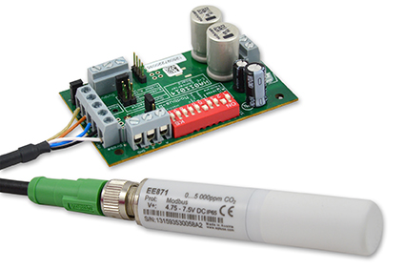
Figure 1: Modular CO₂ transmitter EE870 with interchangeable probe EE871.

Photos: E+E Elektronik GmbH, reprint free of charge

About E+E Elektronik:
E+E Elektronik develops and manufactures sensors and transmitters for humidity, temperature, dewpoint, moisture in oil, air velocity, flow and CO₂. Data loggers, hand-held measuring devices and calibration systems complete the comprehensive product portfolio of the Austrian sensor specialist. The main applications for E+E products lie in HVAC, building automation, industrial process control and the automotive industry. A certified quality management system according to ISO 9001 and ISO/TS 16949 ensures the highest quality standards. E+E Elektronik has a worldwide dealership network and representative offices in Germany, France, Italy, Korea, China and the United States. The accredited E+E calibration laboratory (OEKD) has been commissioned by the Austrian Federal Office for Metrology (BEV)) to provide the national standards for humidity and air velocity.

Contact: www.epluse.com, info@epluse.at, T: +43 (0) 7235 605-0, F: +43 (0) 7235 605-8

For further inquiries: Mr. Johannes Fraundorfer, T: +43 (0)7235 605-217, pr@epluse.at

