Now Also Available as an App for Mobile Devices
Humidity Calculator Calculates Humidity Measurands, including Measurement Uncertainties

(Engerwitzdorf, 23.06.2016) With the online humidity calculator from E+E Elektronik, humidity-related parameters can be calculated quickly and easily. In contrast to other programs, it takes into account the measurement uncertainties. The E+E humidity calculator is now also available as a free app for mobile devices. The app for Android or iOS operating systems can be downloaded from the Google Play or Apple App Store. The app also features a pressure dew point calculator.

Based on known ambient conditions, the E+E humidity calculator converts among all humidity-related parameters, such as relative humidity, dew point / frost point temperature, water vapour density, mixing ratio, partial water vapour pressure and specific enthalpy. Calculations can be made in metric (SI) as well as imperial (US) units.

Unique is that the E+E humidity calculator takes into account measurement uncertainties in the calculation. This means that realistic and reliable total uncertainties can be calculated based on the accuracy specification of the measuring device.

The app also features a pressure dew point calculator specifically tailored for compressed air applications.

Thanks to the intuitive operation the humidity calculator is very easy to use. The conversions and calculations can be saved or sent as a PDF. The online humidity calculator (www.humidity-calculator-online.com) also offers the option of copying the results to an Excel file. The online version of the E+E Humidity Calculator is available in 8 languages, while the app is available in German and English.

Characters (no spaces): 1456
Words: 253

Images
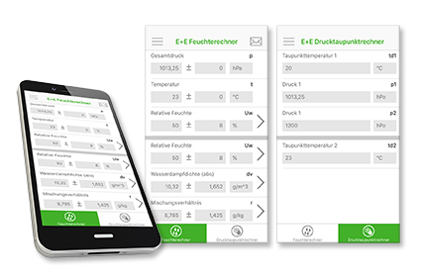

Figure 1: The E+E humidity calculator app for mobile devices.

Photos: E+E Elektronik Ges.m.b.H., reprint free of charge

About E+E Elektronik:
E+E Elektronik develops and manufactures sensors and transmitters for humidity, temperature, dewpoint, moisture in oil, air velocity, flow and CO₂. Data loggers, hand-held measuring devices and calibration systems complete the comprehensive product portfolio of the Austrian sensor specialist. The main applications for E+E products lie in HVAC, building automation, industrial process control and the automotive industry. A certified quality management system according to ISO 9001 and ISO/TS 16949 ensures the highest quality standards. E+E Elektronik has a worldwide dealership network and representative offices in Germany, France, Italy, Korea, China and the United States. The accredited E+E calibration laboratory (OEKD) has been commissioned by the Austrian Federal Office for Metrology (BEV) to provide the national standards for humidity and air velocity.

Contact: www.epluse.com, info@epluse.at, T: +43 (0) 7235 605-0, F: +43 (0) 7235 605-8

For further inquiries: Mr. Johannes Fraundorfer, T: +43 (0)7235 605-217, pr@epluse.at

