Ex transmitter with KC certificate for Korea
The EE300Ex humidity and temperature transmitter features now also the Korean Certification Mark (KC)

(Engerwitzdorf, 13.07.2017) The intrinsically safe EE300Ex humidity and temperature transmitter from E+E Elektronik now also bears the “Korean Certification Mark” (KC) required in Korea. The KC certification is comparable with the European ATEX, the American FM or the Japanese TIIS approvals already available for EE300Ex.

The EE300Ex is dedicated for highly accurate humidity and temperature measurement in potentially explosive environment. The transmitter is available for wall mounting or with remote probe and can be mounted directly in both gas and dust hazardous areas of zone 0 / 20. The two-part enclosure facilitates easy installation and rapid replacement of the measurement unit for servicing or calibration.

The enclosure and the sensing probes are made of high-quality stainless steel, which makes the transmitter suitable for both demanding industrial applications and for clean rooms. Depending on the choice of sensing probe, the EE300Ex can be used for combined humidity and temperature measurement, for temperature measurement only, or for moisture measurement in oil. Accurate measurement in the range 0 to 100% RH (0 to 1 aw for moisture in oil) and -40 to 180°C (-40…356 °F) are possible at a pressure of up to 300 bar (4351 psi).

The E+E proprietary coating is a key feature when it comes to harsh working conditions. The coating protects the sensor from contamination and corrosion, thereby relevantly improving the long-term stability and the lifetime.

The measured humidity and temperature values, as well as calculated measurands like dew point, frost point, absolute humidity or mixing ratio are available on two analogue outputs and on the optional display.

Further information about the EE300Ex transmitter can be found online at: www.intrinsically-safe-measurement.com

Characters (incl. spaces): 1944
Words: 292

Images:

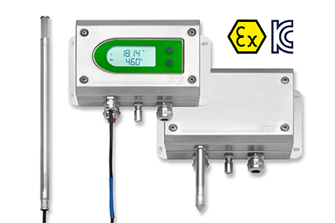
Intrinsically safe EE300Ex transmitter with KC certificate for Korea

Photos: E+E Elektronik GmbH, reprint free of charge

E+E Elektronik develops and manufactures sensors and transmitters for humidity, temperature, dewpoint, moisture in oil, air velocity, flow and CO₂. Data loggers, hand-held measuring devices and calibration systems complete the comprehensive product portfolio of the Austrian sensor specialist. The main applications for E+E products lie in HVAC, building automation, industrial process control and the automotive industry. A certified quality management system according to ISO 9001 and ISO/TS 16949 ensures the highest quality standards. E+E Elektronik has a worldwide dealership network and representative offices in Germany, France, Italy, Korea, China and the United States. The accredited E+E calibration laboratory (OEKD) has been commissioned by the Austrian Federal Office for Metrology (BEV) to provide the national standards for humidity and air velocity.

E+E Elektronik Ges.m.b.H
Langwiesen 7
4209 Engerwitzdorf
Austria
T: +43 (0) 7235 605-0
F: +43 (0) 7235 605-8
info@epluse.at
www.epluse.com

Press contact:
Mr. Johannes Fraundorfer
T: +43 (0)7235 605-217
pr@epluse.at

