Early Warning of Condensation Danger
The EE046 condensation monitor indicates condensation danger before condensation actually occurs. It is ideal for monitoring chilled beams and other surfaces operated close to the dew point.

(Engerwitzdorf, 20.04.2017) The compact EE046 from E+E Elektronik monitors reliably the condensation danger on chilled beams and other critical cold spots, in air conditioning systems or switching cabinets. It can be installed on plane surfaces and on pipes up to 50 mm (2”) diameter. For preventing condensation, the switch output can trigger actuators like valves or heaters.

The EE046 measures accurately the relative humidity at the surface temperature. Thanks to the special E+E proprietary coating, the humidity sensor is optimally protected against contamination. This improves the lifetime and long-term stability of the EE046 in dirty, dusty environments. Another advantage of the condensation monitor is the fast response time to humidity or surface temperature change.

The potential-free relay (max. 24 V AC/DC, 1 A) switches when the relative humidity at the surface reaches 90% RH, or in case of a supply failure such as a broken cable. A LED indicates the status of the EE046: normal operation, risk of condensation or fault/failure.

Due to the compact design, the condensation monitor requires little space and the installation is remarkably simple. On plane surfaces, the EE046 is fixed with two screws, for mounting on pipes up to 50 mm in diameter a mounting strap is included in the scope of supply.

Characters (incl. spaces): 1543
Words: 240

Images:
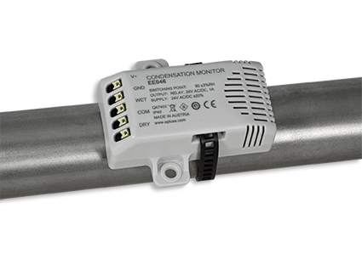
EE046 condensation monitor from E+E Elektronik.

Photos: E+E Elektronik GmbH, reprint free of charge

E+E Elektronik develops and manufactures sensors and transmitters for humidity, temperature, dewpoint, moisture in oil, air velocity, flow and CO₂. Data loggers, hand-held measuring devices and calibration systems complete the comprehensive product portfolio of the Austrian sensor specialist. The main applications for E+E products lie in HVAC, building automation, industrial process control and the automotive industry. A certified quality management system according to ISO 9001 and ISO/TS 16949 ensures the highest quality standards. E+E Elektronik has a worldwide dealership network and representative offices in Germany, France, Italy, Korea, China and the United States. The accredited E+E calibration laboratory (OEKD) has been commissioned by the Austrian Federal Office for Metrology (BEV) to provide the national standards for humidity and air velocity.

E+E Elektronik Ges.m.b.H
Langwiesen 7
4209 Engerwitzdorf
Austria
T: +43 (0) 7235 605-0
F: +43 (0) 7235 605-8
info@epluse.at
www.epluse.com

Press contact:
Mr. Johannes Fraundorfer
T: +43 (0)7235 605-217
pr@epluse.at

