Humidity and temperature transmitter with interchangeable probes
The EE220 can be equipped with intelligent, interchangeable probes. Separate humidity and temperature probes enable highly accurate loop calibration.

(Engerwitzdorf, 24.08.2017) The EE220 transmitter from E+E Elektronik measures relative humidity and temperature in the range from -40 °C to 80 °C (-40 °F to 176 °F) with a high accuracy of ±2 % RH and ±0.1 °C (±0.18 °F). The basis unit can be fitted with various pluggable and interchangeable sensing probes. Separate probes for humidity and temperature enable highly accurate loop calibration. The easy-to-clean metal enclosure and stainless steel probes are ideal for clean room applications and use in the pharmaceutical and food industry.

Probe exchange in a matter of seconds
The EE220 basis unit can be equipped with a combined humidity and temperature probe or two separate probes, one for humidity and one for temperature. The EE07 probes can either be plugged directly onto the basis unit or mounted up to 10 m away using extension cables. Thanks to the plug-in system, the sensing probes can be exchanged in just a few seconds. As the calibration data is stored in the intelligent probes, the transmitter does not need to be re-calibrated after a probe replacement.

Loop calibration according to FDA recommendation
The use of separate stainless steel sensing probes for humidity and temperature enables most accurate loop calibration, as recommended by the FDA (Food and Drug Administration) for the pharmaceutical and biotechnology industry. Using extension cables and without dismounting the EE220 basis unit, the humidity probe can be placed in a portable humidity calibrator and the temperature probe in a dry block calibrator. Thus, the entire measurement chain from the probe to the controller can be calibrated on-site (loop calibration).
The probes can be individually adjusted with buttons on the E220 electronics board. Adjustment and calibration is particularly comfortable using the optional display, which can be simply plugged onto the EE220 board for this purpose.

Accuracy check with reference probes
Two reference probes can be used instead of the regular probes to check the correct functioning and accuracy of the EE220 basis unit. The reference probes simulate defined humidity and temperature values which can be compared with the EE220 outputs.

Optimum sensor protection
The optional E+E proprietary coating is brings relevant benefits in harsh ambient conditions. It protects the sensing elements from dirt, dust and corrosion, thereby considerably improving the long-term stability and lifetime.

Options and accessories
The EE220 basis unit and the EE07 sensing probes are available with polycarbonate or stainless steel enclosure. The current measured data is available locally on the optional display. The EE220 is suitable for wall mounting and rail installation according to DIN EN 50002. A duct mounting kit is also available.

Characters (incl. spaces): 2968
Words: 456

Images:
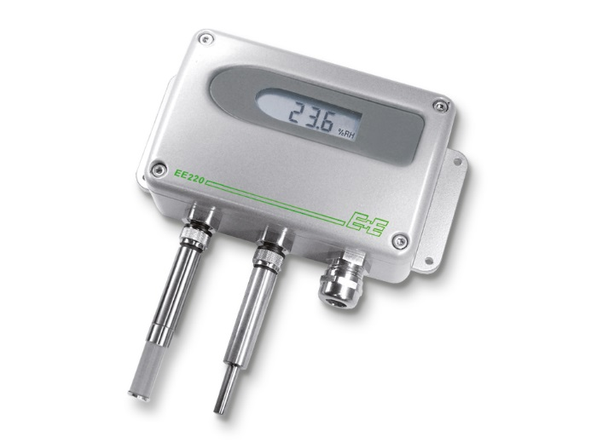 | 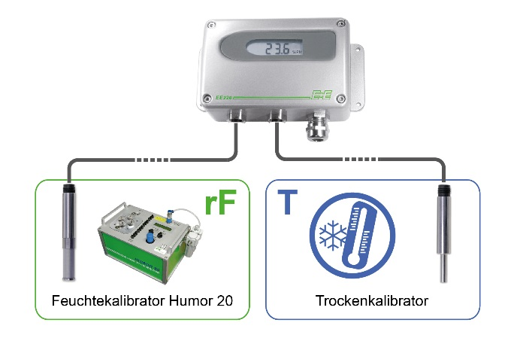
Figure 1:  EE220 in metal enclosure with separate sensing probes for humidity and temperature. | Figure 2:  The EE220 enables separate calibration of the humidity and temperature probe (loop calibration).

Photos: E+E Elektronik Ges.m.b.H., reprint free of charge

E+E Elektronik develops and manufactures sensors and transmitters for humidity, temperature, dewpoint, moisture in oil, air velocity, flow and CO₂. Data loggers, hand-held measuring devices and calibration systems complete the comprehensive product portfolio of the Austrian sensor specialist. The main applications for E+E products lie in HVAC, building automation, industrial process control and the automotive industry. A certified quality management system according to ISO 9001 and ISO/TS 16949 ensures the highest quality standards. E+E Elektronik has a worldwide dealership network and representative offices in Germany, France, Italy, Korea, China and the United States. The accredited E+E calibration laboratory (OEKD) has been commissioned by the Austrian Federal Office for Metrology (BEV) to provide the national standards for humidity and air velocity.

E+E Elektronik Ges.m.b.H
Langwiesen 7
4209 Engerwitzdorf
Austria
T: +43 (0) 7235 605-0
F: +43 (0) 7235 605-8
info@epluse.at
www.epluse.com

Press contact:
Mr. Johannes Fraundorfer
T: +43 (0)7235 605-217
pr@epluse.at

