High-End Humidity and Temperature Transmitter with Multi-Functional Display
The EE310 industrial transmitter measures humidity and temperature up to 180°C (356 °F). The multi-functional display gives full information on current and recorded measured data.

(Engerwitzdorf, 22.2.2017) The highly accurate EE310 humidity and temperature transmitter from E+E Elektronik is dedicated for demanding process control. The modern multi-functional display with data logging function enables intuitive operation and offers an optimum overview of the measuring task. Extensive settings and diagnostics can thus be performed directly on the device.

The EE310 measures relative humidity and temperature, and calculates dew point temperature, frost point temperature, wet-bulb temperature, water vapour partial pressure, mixing ratio, absolute humidity and specific enthalpy.

The 3.5” TFT colour display shows simultaneously up to four measured or calculated values. All settings and even error diagnosis are easily performed with push buttons. The integrated data logger stores up to 20,000 values per measurand. The recorded data can be shown on the display, or downloaded via the USB interface for further processing.

The EE310 transmitter is available for wall or duct mount, as well as with remote probe. Various remote probes can be employed up to 180 °C (356 °F) and 20 bar (290 psi). The probes are also available as pluggable versions for quick and easy replacement.

The E+E proprietary sensor coating brings relevant advantages when it comes to use in harsh industrial environment. It protects the sensing elements from corrosive and electrically conductive contamination, which leads to reliable and long-term stable measurements.

The modular enclosure simplifies installation and maintenance of the EE310. The upper part of the transmitter, which accommodates the electronics and the probe, can be easily plugged off for service or adjustment, while the wiring remains untouched.

The measured values are available on two analogue outputs and the Modbus RTU interface. Two freely configurable relay outputs can be used for control or alarm purposes. Configuration and adjustment of the transmitter can be performed via display or with the free EE-PCS software using the USB interface.

More information about the EE310: www.ee310-humidity-transmitter.com

Characters (incl. spaces): 2345
Words: 340

Images:

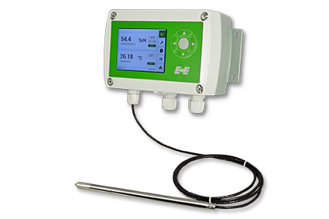
EE310 Humidity and temperature transmitter from E+E Elektronik.

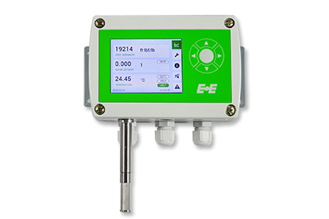
EE310 Wall-mount version with 3.5“ TFT colour display.

Photos: E+E Elektronik GmbH, reprint free of charge

E+E Elektronik develops and manufactures sensors and transmitters for humidity, temperature, dewpoint, moisture in oil, air velocity, flow and CO₂. Data loggers, hand-held measuring devices and calibration systems complete the comprehensive product portfolio of the Austrian sensor specialist. The main applications for E+E products lie in HVAC, building automation, industrial process control and the automotive industry. A certified quality management system according to ISO 9001 and ISO/TS 16949 ensures the highest quality standards. E+E Elektronik has a worldwide dealership network and representative offices in Germany, France, Italy, Korea, China and the United States. The accredited E+E calibration laboratory (OEKD) has been commissioned by the Austrian Federal Office for Metrology (BEV) to provide the national standards for humidity and air velocity.

E+E Elektronik Ges.m.b.H
Langwiesen 7
4209 Engerwitzdorf
Austria
T: +43 (0) 7235 605-0
F: +43 (0) 7235 605-8
info@epluse.at
www.epluse.com

Press contact:
Mr. Johannes Fraundorfer
T: +43 (0)7235 605-217
pr@epluse.at

