Transmitter for Moisture in Oil Monitoring
The EE360 moisture in oil transmitter measures accurately the moisture content in hydraulic, lubrication and insulation oils as well as diesel fuel.

(Engerwitzdorf, 22.03.2017) The EE360 moisture in oil transmitter from E+E Elektronik is dedicated for reliable monitoring of lubrication, hydraulic and insulation oils as well as diesel fuel. The device measures water activity and temperature, and calculates the absolute water content of the oil. The probe can be employed up to 180 °C (356 °F) and 20 bar (290 psi). The colour display shows actual as well as logged measured data.

The well proven E+E sensing technology ensure highly accurate measurement of water activity (aw) and temperature (T). Based on the measured values and on oil-specific parameters, the EE360 calculates the absolute water content (x) in ppm.

On the 3.5 "TFT colour display all three physical quantities can be read simultaneously. The integrated data logger stores 20,000 values per measurand, which can be shown as graph on the display. This means that, beside current data, the user can keep an eye on the oil condition trend.

The stainless steel probe can be installed into the process with an ISO or NPT slide fitting, which facilitates the accurate control of the immersion depth. Using the optional ball valve, the probe can be mounted or removed even without process interruption. The pluggable probe version allows for easy installation and replacement.

The measured data is available on two analogue outputs or on the digital Modbus RTU interface. The configuration of the outputs as well as the humidity and temperature adjustment can be easily performed via display and push buttons. Extensive error information and diagnosis are available on the display as well as via status LEDs and acoustic warnings. Two optional relay outputs can be used for alarm or control purposes.

Comfortable setup and adjustment of the EE360 is also possible with a computer and the free EE-PCS configuration software. The USB service interface is used as well to download logged data and perform firmware updates.

The modular IP65 enclosure facilitates mounting and maintenance of the transmitter. The evaluation unit, which accommodates the electronics and the probe, can be replaced within seconds, while the wiring remains untouched. The material of the enclosure is approved according to UL94-V0.

More information about E+E moisture in oil transmitters on www.moisture-in-oil-sensors.com.

Characters (incl. spaces): 2499
Words: 390

Images:

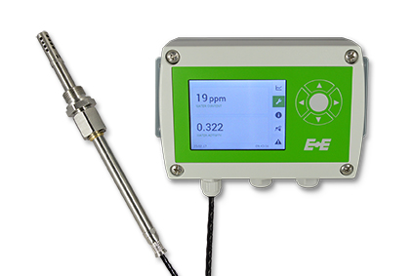
EE360 moisture in oil transmitter from E+E Elektronik.

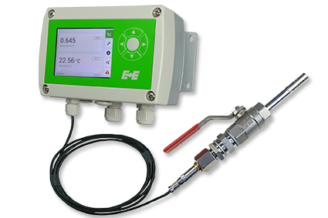
EE360 transmitter with ball valve mounting set.

Photos: E+E Elektronik GmbH, reprint free of charge

E+E Elektronik develops and manufactures sensors and transmitters for humidity, temperature, dewpoint, moisture in oil, air velocity, flow and CO₂. Data loggers, hand-held measuring devices and calibration systems complete the comprehensive product portfolio of the Austrian sensor specialist. The main applications for E+E products lie in HVAC, building automation, industrial process control and the automotive industry. A certified quality management system according to ISO 9001 and ISO/TS 16949 ensures the highest quality standards. E+E Elektronik has a worldwide dealership network and representative offices in Germany, France, Italy, Korea, China and the United States. The accredited E+E calibration laboratory (OEKD) has been commissioned by the Austrian Federal Office for Metrology (BEV) to provide the national standards for humidity and air velocity.

E+E Elektronik Ges.m.b.H
Langwiesen 7
4209 Engerwitzdorf
Austria
T: +43 (0) 7235 605-0
F: +43 (0) 7235 605-8
info@epluse.at
www.epluse.com

Press contact:
Mr. Johannes Fraundorfer
T: +43 (0)7235 605-217
pr@epluse.at

