Air Flow Probe with Modbus Interface
Easy integration into modern building automation systems

(Engerwitzdorf, 17.01.2016) The EE671 compact air flow probe from E+E Elektronik measures air velocity up to 20 m/s (4000 ft/m) and is ideal for HVAC applications. The new version with Modbus RTU interface facilitates the EE761 integration into modern building automation systems.

The EE671 probe is dedicated for reliable air flow measurement in heating and ventilation systems. It features the new E+E VTQ thin-film flow sensing element. Due to innovative transfer molding, the sensing element is very robust and highly insensitive to contamination, which allows accurate and long-term stable measurements even under harsh conditions.

The probe is available with fixed cable or M12 connector. The alignment strip and the matching mounting flange allow for easy installation and precise positioning of the EE671 in the ventilation duct. The sensing head design is optimized for low angle dependency.

In addition to the Modbus version, the EE671 is also available with voltage output 0-1 V, 0-5 V or 0-10V. An optional configuration kit makes it easy to scale the output, set the Modbus parameters and perform the adjustment of EE671.

Characters (no spaces): 1039
Words: 190

Images
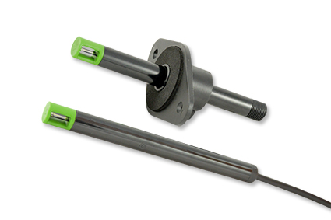
Figure 1: EE671 Miniature air flow transmitter.

Photos: E+E Elektronik GmbH, reprint free of charge

About E+E Elektronik:
E+E Elektronik develops and manufactures sensors and transmitters for humidity, temperature, dewpoint, moisture in oil, air velocity, flow and CO₂. Data loggers, hand-held measuring devices and calibration systems complete the comprehensive product portfolio of the Austrian sensor specialist. The main applications for E+E products lie in HVAC, building automation, industrial process control and the automotive industry. A certified quality management system according to ISO 9001 and ISO/TS 16949 ensures the highest quality standards. E+E Elektronik has a worldwide dealership network and representative offices in Germany, France, Italy, Korea, China and the United States. The accredited E+E calibration laboratory (OEKD) has been commissioned by the Austrian Federal Office for Metrology (BEV) to provide the national standards for humidity and air velocity.

Contact: www.epluse.com, info@epluse.at, T: +43 (0) 7235 605-0, F: +43 (0) 7235 605-8

For further inquiries: Mr. Johannes Fraundorfer, T: +43 (0)7235 605-217, pr@epluse.at

