Flow Meter Identifies Potential Savings in Compressed Air Supply
The modular EE741 flow meter ensures cost transparency in compressed air consumption. The compact device can be used for pipe diameters DN15 to DN50.

(Engerwitzdorf, 24.10.2017) The monitoring of compressed air consumption ensures cost transparency and helps cutting energy costs by identifying potential savings. The EE741 in-line flow meter from E+E Elektronik is ideal for measuring the consumption of compressed air and technical gases. Due to its modular design, the compact device is suitable for pipe diameters from DN15 to DN50 (1/2” to 2”). The thermal hot-film anemometer measuring principle provides high accuracy and reliability.

For pipe diameters DN15 to DN50
The modular EE741 consists of the transmitter unit with flow sensor and a stainless steel or aluminum gauge mounting block. The mounting blocks are available for DN15 (1/2”), DN20 (3/4”), DN25 (1”) and now also for DN32 (1 1/4”), DN40 (1 1/2”), DN50 (2”) pipes.
The gauge mounting block enables easy and reproducible positioning of the transmitter in pipes with an operating pressure up to 16 bar (232 psi). Outstanding measuring accuracy, even in the lower measuring range, is achieved by the application-specific multi-point factory adjustment at 7 bar (102 psi). This allows precise leak detection and the consequent energy savings. The EE741 features an integrated consumption meter for cost-effective consumption monitoring without an additional data logger.

Easy installation and removal
Once the gauge mounting block is built into the pipeline, the transmitter can be easily removed and installed without disassembling the pipework. This is particularly useful for periodical calibration. Besides, one transmitter can be used for temporary measurements at several gauge mounting blocks. The sealing plug included in the scope of supply enables the operation of the compressed air system when the transmitter unit is removed. The robust stainless steel sensing head protects the sensing element against mechanical damage during installation or removal.

Highly accurate thermal measuring principle
The EE741 works on the thermal hot-film anemometer principle. The E+E thin-film sensing element stands out by excellent long-term stability and short response time. The measuring principle is largely insensitive to contamination and eliminates the need for additional pressure or temperature compensation. The EE741 also measures the standard volume flow, mass flow, standard flow and temperature of non-corrosive gases such as nitrogen, oxygen, helium, CO₂ or argon.

Comfortable operation via display
The optional display shows the actual measured data as well as the total consumption. The entire device setup can be performed with the display and the push buttons. For optimum readability the display alignment can be rotated in 90° increments. An EE741 without display can be configured via USB service interface using the free EE-PCS product configuration software.

Several output options
The EE741 features two outputs, which can be configured for analogue, pulse or alarm signals. Optionally, the flow meter is available with a Modbus RTU or M-Bus interface.

Characters (incl. spaces): 3197
Words: 479

Images:

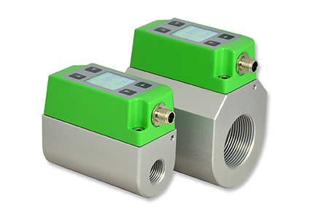 | 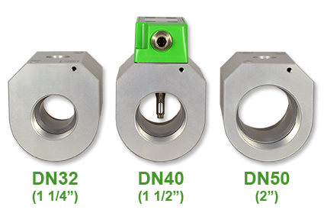
Image 1: The EE741 flow meter measures and monitors the compressed air consumption with high accuracy. | Image 2: New gauge mounting blocks for DN32 (1 1/4”), DN40 (1 1/2”) and DN50 (2”) extend the application range of the EE741.

Photos: E+E Elektronik GmbH, reprint free of charge

E+E Elektronik develops and manufactures sensors and transmitters for humidity, temperature, dewpoint, moisture in oil, air velocity, flow and CO₂. Data loggers, hand-held measuring devices and calibration systems complete the comprehensive product portfolio of the Austrian sensor specialist. The main applications for E+E products lie in HVAC, building automation, industrial process control and the automotive industry. A certified quality management system according to ISO 9001 and ISO/TS 16949 ensures the highest quality standards. E+E Elektronik has a worldwide dealership network and representative offices in Germany, France, Italy, Korea, China and the United States. The accredited E+E calibration laboratory (OEKD) has been commissioned by the Austrian Federal Office for Metrology (BEV) to provide the national standards for humidity and air velocity.

E+E Elektronik Ges.m.b.H
Langwiesen 7
4209 Engerwitzdorf
Austria
T: +43 (0) 7235 605-0
F: +43 (0) 7235 605-8
info@epluse.at
www.epluse.com

Press contact:
Mr. Johannes Fraundorfer
T: +43 (0)7235 605-217
pr@epluse.at

