Heated Humidity Sensor for Radiosondes
Due to its short response time at low temperature the HMC03M humidity sensor is optimal for weather observation in the upper atmosphere.

(Engerwitzdorf, 24.05.2017) The HMC03M humidity sensor from E+E Elektronik is dedicated for use in radiosondes and weather balloons. The sensor is characterized by a short response time even at low temperature. An integrated heating resistor ensures an excellent measuring performance under condensation and icing conditions. This makes the sensor ideal for weather observations in the upper atmosphere.

The HMC03M combines on a silicon substrate a capacitive relative humidity (RH) sensor and a heating resistor. By heating, the sensor quickly recovers after condensation or icing, which leads to a very good measuring performance even under extreme weather conditions. Another key feature of the HMC03M is the short response time at very low temperature.
As a result, the HMC03M is ideal for use in radiosondes to measure humidity in the upper atmosphere.

The 5.85 x 2.85 mm small SMD sensor is appropriate for automatic assembling with subsequent reflow soldering. HMC03M is available on tape and reel of 500, 1000 or 2500 pcs.

Also humidity probes and transmitters for meteorology

E+E Elektronik’s product range for meteorology also includes probes and transmitters for highly accurate humidity and temperature measurement. The sensing elements of these devices are well protected from pollution and corrosion by the proprietary E+E coating. This leads to improved long-term stability and a longer lifetime, two essential criteria for long-term use in weather stations.

At www.meteorology-sensors.com E+E Elektronik offers a brief overview of its meteorological products.

Characters (incl. spaces): 1743
Words: 261

Images:
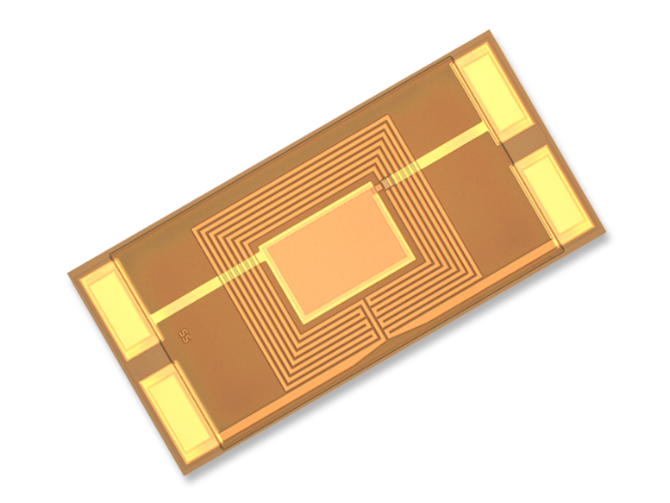

Image 1: HMC03M heated humidity sensor for radiosondes

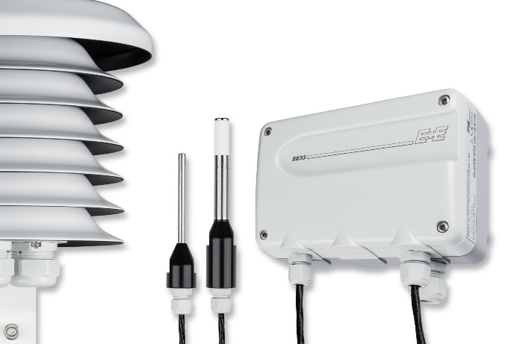

Image 2: EE33-M humidity and temperature transmitter for weather stations.

Photos: E+E Elektronik GmbH, reprint free of charge

E+E Elektronik develops and manufactures sensors and transmitters for humidity, temperature, dewpoint, moisture in oil, air velocity, flow and CO₂. Data loggers, hand-held measuring devices and calibration systems complete the comprehensive product portfolio of the Austrian sensor specialist. The main applications for E+E products lie in HVAC, building automation, industrial process control and the automotive industry. A certified quality management system according to ISO 9001 and ISO/TS 16949 ensures the highest quality standards. E+E Elektronik has a worldwide dealership network and representative offices in Germany, France, Italy, Korea, China and the United States. The accredited E+E calibration laboratory (OEKD) has been commissioned by the Austrian Federal Office for Metrology (BEV) to provide the national standards for humidity and air velocity.

E+E Elektronik Ges.m.b.H
Langwiesen 7
4209 Engerwitzdorf
Austria
T: +43 (0) 7235 605-0
F: +43 (0) 7235 605-8
info@epluse.at
www.epluse.com

Press contact:
Mr. Johannes Fraundorfer
T: +43 (0)7235 605-217
pr@epluse.at

