Humidity Transmitters with Ethernet Interface
The EE310 and EE360 industrial transmitters can now be integrated into a network via Ethernet interface.

(Engerwitzdorf, 8.3.2018) Beside the RS485 interface with Modbus RTU protocol, the EE310 humidity and temperature transmitter and the EE360 moisture in oil transmitter from E+E Elektronik now feature an Ethernet interface with Modbus TCP protocol.

The EE310 and EE360 represent the latest generation of industrial transmitters from the Austrian sensor specialist E+E Elektronik. A multi-functional 3.5" TFT colour display provides a comprehensive overview of the measurement task and allows the user to perform all settings directly on the device. An integrated data logger stores up to 20,000 values per measurand.

Ethernet and RS485 Interfaces
As a standard, the measured data is available on two voltage or current outputs. The devices can be optionally fitted with an RS485 module with Modbus RTU protocol or with an Ethernet module with Modbus TCP protocol. The interface settings can be performed with a PC using the free configuration software or directly on the device via display and push buttons. The Ethernet module features Power over Ethernet (PoE) and an IP65 rated RJ45 connector. Both interface modules are available also for retrofitting.

EE310 Humidity and Temperature Transmitter
The EE310 measures relative humidity and temperature and calculates dew point temperature, frost point temperature, wet-bulb temperature, water vapour partial pressure, mixing ratio, absolute humidity and specific enthalpy. The transmitter is available for wall or duct mount, as well as with remote probes. The probes can be employed up to 180 °C (356 °F) and 20 bar (290 psi). Pluggable probe versions allow for quick and easy replacement.

EE360 Moisture in Oil Transmitter
The EE360 is dedicated for monitoring the moisture content in hydraulic, lubrication and insulation oils as well as diesel fuel. The device measures water activity (a_{w}) and temperature (T), and calculates the absolute water content (x) in ppm. The stainless steel probe can be installed into the process with an ISO or NPT slide fitting, which facilitates the accurate control of the immersion depth. Using the optional ball valve, the probe can be mounted or removed even without process interruption.

Service-Friendly Design
The modular IP65 enclosure facilitates installation and maintenance. The active part of the device, which accommodates the electronics and the probe, can be replaced within seconds while the back cover and the electrical connection remain untouched.

Characters (incl. spaces): 2594
Words: 394

Images:

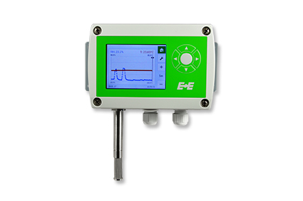 | 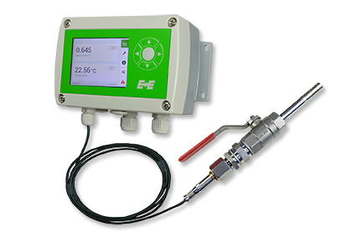
Image 1:  EE310 humidity and temperature transmitter (wall mount) | Image 2:  EE360 moisture in oil transmitter with ball valve mounting set

Photos: E+E Elektronik GmbH, reprint free of charge

E+E Elektronik develops and manufactures sensors and transmitters for humidity, temperature, dewpoint, moisture in oil, air velocity, flow and CO₂. Data loggers, hand-held measuring devices and calibration systems complete the comprehensive product portfolio of the Austrian sensor specialist. The main applications for E+E products lie in HVAC, building automation, industrial process control and the automotive industry. A certified quality management system according to ISO 9001 and ISO/TS 16949 ensures the highest quality standards. E+E Elektronik has a worldwide dealership network and representative offices in Germany, France, Italy, Korea, China and the United States. The accredited E+E calibration laboratory (OEKD) has been commissioned by the Austrian Federal Office for Metrology (BEV) to provide the national standards for humidity and air velocity.

E+E Elektronik Ges.m.b.H
Langwiesen 7
4209 Engerwitzdorf
Austria
T: +43 (0) 7235 605-0
F: +43 (0) 7235 605-8
info@epluse.at
www.epluse.com

Press contact:
Mr. Johannes Fraundorfer
T: +43 (0)7235 605-217
pr@epluse.at

