Humidity Measurement Module for OEM Applications
The EE1900 humidity measurement module is optimised for climate and test chambers. The sensor copes well with pollution and chemical contamination.

(Engerwitzdorf, 26.7.2018) The EE1900 humidity module from E+E Elektronik is optimised for the measurement of relative humidity (RH) or dew point temperature (Td) in climate and test chambers. With outstanding temperature compensation across the working range from -70 °C to 180 °C (-94 °F to 356 °F) and the choice of stainless steel and plastic probes, the module is suitable for a wide range of applications.

High Accuracy in Harsh Environment
The excellent measuring accuracy of the EE1900 rests on the innovative E+E humidity and temperature sensing element HMC01. The proprietary E+E coating protects the sensor from dust, dirt and corrosive agents. Therefore, the EE1900 module features excellent long-term stability even in harsh environment.

Chemical Purge
Thanks to the Automatic Sensor Recovery (ARC) function, the sensor copes well with chemical contamination. By controlled, strong heating, the chemicals gaze out from the sensing element. After the ARC cycle, the sensor quickly returns to normal measurement conditions. The ARC mode can be triggered either via a push button on the board or an electrical signal.

Comfortable Configuration and Adjustment
The EE1900 module features an analogue output, which can be set to current or voltage with a slide switch. The service interface allows for output scaling and adjustment of the humidity measurement. The product configuration software EE-PCS is available free of charge on the E+E website. The operating mode of the module is indicated by status LEDs as well as by the output and status signals.

Stainless Steel or Plastic Probe
The EE1900 is available with either stainless steel or plastic (PPS) probe. The high quality, flexible probe cable up to 3m length facilitates the probe installation.

With two sizes of the electronics board (55 x 46.5 mm / 2.17 x 1.83 ʺ or 90 x 70 mm / 3.54 x 2.76 ʺ), the humidity measurement module can be easily integrated into existing climate chambers.

Characters (incl. spaces): 2143
Words: 339

Images:
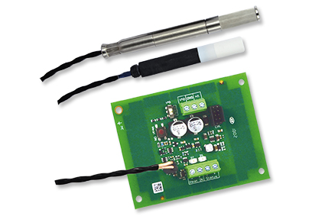

Image: The EE1900 humidity measurement module is available with a stainless steel or plastic probe.

Photos: E+E Elektronik GmbH, reprint free of charge

E+E Elektronik develops and manufactures sensors and transmitters for humidity, temperature, dew point, moisture in oil, air velocity, flow, CO₂ and pressure. Data loggers, hand-held measuring devices and calibration systems complete the comprehensive product portfolio of the Austrian sensor specialist. The main applications for E+E products lie in HVAC, building automation, industrial process control and the automotive industry. A certified quality management system according to ISO 9001 and ISO/TS 16949 ensures the highest quality standards. E+E Elektronik has a worldwide dealership network and representative offices in Germany, France, Italy, Korea, China and the United States. The accredited E+E calibration laboratory (OEKD) has been commissioned by the Austrian Federal Office for Metrology (BEV) to provide the national standards for humidity and air velocity.

E+E Elektronik Ges.m.b.H
Langwiesen 7
4209 Engerwitzdorf
Austria
T: +43 (0) 7235 605-0
F: +43 (0) 7235 605-8
info@epluse.at
www.epluse.com

Press contact:
Mr. Johannes Fraundorfer
T: +43 (0)7235 605-217
pr@epluse.at

