Dew Point Measurement Module for High Humidity Applications
The EE1950 is optimized for accurate dew point measurement at high humidity conditions. It is therefore an ideal solution for climate chambers.

(Engerwitzdorf, 22.11.2018) The EE1950 dew point measurement module from E+E Elektronik is dedicated for OEM applications with continuous high humidity and condensing conditions, such as climate and test chambers. Excellent temperature compensation ensures high accuracy over the entire working range from -70 °C to 180 °C (-94 °F to 356 °F). The device is also particularly resistant to pollutants and corrosive agents.

Optimized for High-Humidity Conditions
The EE1950 employs the innovative, heated E+E humidity and temperature sensing element HMC01, which shows best long-term stability even at continuous high relative humidity. Besides, the proprietary E+E coating protects the sensing element from dust, dirt and corrosion. This improves significantly the measurement performance in harsh environment.

Precise Calculation of Relative Humidity
Together with an additional, external temperature sensor, the EE1950 allows for precise calculation of the relative humidity. It is therefore a perfect solution for climatic chamber control.

High Resistance to Chemical Contamination
Thanks to the Automatic Sensor Recovery (ARC) function, the sensor copes well with chemical contamination. By controlled heating, the chemicals gaze out from the sensing element, which improves the long-term stability and service life of the device. The ARC mode can be triggered either via a push button on the board or an electrical signal.

User-Friendly Configuration and Adjustment
The dew point measured data is available on the analogue output, which can be set to current or voltage with a slide switch. The output scaling and adjustment can be easily performed via the service interface and the free EE-PCS configuration software.

Easy Design-In
The choice of two board sizes (55 x 46.5 mm / 2.17 x 1.83 ʺ or 90 x 70 mm / 3.54 x 2.36 ʺ) and the high-quality, flexible probe cable facilitate the design-in of the EE1950. The stainless steel probe is available in 65 mm (2.56 ʺ) and 200 mm (7.84 ʺ) length.

Characters (incl. spaces): 2190
Words: 337

Images:
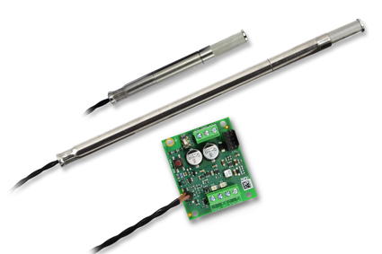

EE1950 dew point measurement module for high humidity applications.

Photos: E+E Elektronik GmbH, reprint free of charge

E+E Elektronik develops and manufactures sensors and transmitters for humidity, temperature, dew point, moisture in oil, air velocity, flow and CO₂. Data loggers, hand-held measuring devices and calibration systems complete the comprehensive product portfolio of the Austrian sensor specialist. The main applications for E+E products lie in HVAC, building automation, industrial process control and the automotive industry. A certified quality management system according to ISO 9001 and IATF 16949 ensures the highest quality standards. E+E Elektronik has a worldwide dealership network and representative offices in Germany, France, Italy, Korea, China and the United States. The accredited E+E calibration laboratory (OEKD) has been commissioned by the Austrian Federal Office for Metrology (BEV) to provide the national standards for humidity and air velocity.

E+E Elektronik Ges.m.b.H
Langwiesen 7
4209 Engerwitzdorf
Austria
T: +43 (0) 7235 605-0
F: +43 (0) 7235 605-8
info@epluse.at
www.epluse.com

Press contact:
Mr. Johannes Fraundorfer
T: +43 (0)7235 605-217
pr@epluse.at

