New Humidity and Temperature Transmitter Up to 180 °C
With the new EE23-T5, E+E Elektronik expands their transmitter series for humidity and temperature. The device can be used up to 180 °C (356 °F).

(Engerwitzdorf, 10.10.2018) The EE23 industrial transmitters from E+E Elektronik measure relative humidity and temperature and also calculate the dew point and frost point temperature. The new model EE23-T5 is suitable for a temperature range of -40 °C to 180 °C (-40 °F to 356 °F) and thus expands the application range of the proven transmitter series. The high-quality E+E humidity sensor with optional sensor coating ensures most accurate and long-term stable measurements.

Range of Different Models
The EE23 series includes models for wall or duct mount as well as different remote probe versions. This makes the transmitter series particularly versatile. Depending on requirements, the devices are available with a robust IP65 / NEMA 4 rated polycarbonate or metal enclosure.

Installation and Service-Friendly Design
The three parts enclosure design facilitates easy installation, service and replacement of the EE23. The enclosure consists of the back cover with the terminals for wiring, the pluggable active part with the electronics and the probe, and the front cover. For service only the active part needs to be replaced, while the back cover with the wiring remains untouched.

Sensor Protection for Use in Harsh Environment
The E+E proprietary coating protects the sensing elements against corrosive and electrically conductive pollution, which leads to outstanding long-term stability even in harsh environment. There is also a wide choice of filter caps available.

Various Additional Options
The measured data is provided on two current or voltage outputs. An optional relay can be used for alarm and control tasks. A display and an integrated power supply module are further optional features of the EE23 devices.

The user can easily perform a two-point humidity and temperature adjustment. The analogue outputs and the relay output can be freely configured.

Characters (incl. spaces): 2064
Words: 320

Images:

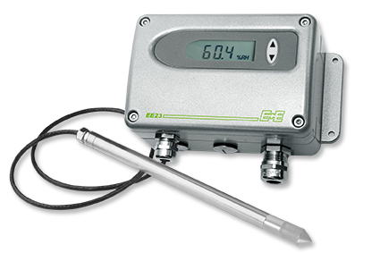
EE23 humidity and temperature transmitter with metal enclosure.

Photos: E+E Elektronik GmbH, reprint free of charge

E+E Elektronik develops and manufactures sensors and transmitters for humidity, temperature, dewpoint, moisture in oil, air velocity, flow and CO₂. Data loggers, hand-held measuring devices and calibration systems complete the comprehensive product portfolio of the Austrian sensor specialist. The main applications for E+E products lie in HVAC, building automation, industrial process control and the automotive industry. A certified quality management system according to ISO 9001 and IATF 16949 ensures the highest quality standards. E+E Elektronik has a worldwide dealership network and representative offices in Germany, France, Italy, Korea, China and the United States. The accredited E+E calibration laboratory (OEKD) has been commissioned by the Austrian Federal Office for Metrology (BEV) to provide the national standards for humidity and air velocity.

E+E Elektronik Ges.m.b.H
Langwiesen 7
4209 Engerwitzdorf
Austria
T: +43 (0) 7235 605-0
F: +43 (0) 7235 605-8
info@epluse.at
www.epluse.com

Press contact:
Mr. Johannes Fraundorfer
T: +43 (0)7235 605-217
pr@epluse.at

