Humidity Transmitters with Stainless Steel Enclosure
The EE310 humidity and temperature transmitter and the EE360 moisture in oil transmitter are now available with stainless steel enclosure.

(Engerwitzdorf, 11.12.2018) The high-end EE310 and EE360 industrial transmitters from E+E Elektronik are now available with stainless steel or with polycarbonate enclosure. The EE310 humidity and temperature transmitter is dedicated for demanding industrial processes control. The EE360 measures the moisture content of industrial oils and thus enables predictive maintenance of machines and plants.

Display with Data Logger Function
Both devices feature an optional 3.5" TFT color display, which offers an optimal view of the measured values and facilitates the commissioning and configuration. The built-in data logger can save 20,000 values per measurand. The recorded data can be displayed as a graph directly on the display or downloaded via USB interface for further analysis.

Analogue Outputs and Digital Interface
The measured data is available on two analogue outputs and on the optional digital interface (RS485 with Modbus RTU or Ethernet with Modbus TCP). An optional relay module can be used for alarms and process control.

Easy Installation and Service
The enclosure design facilitates installation and maintenance. The front cover, which accommodates the electronics and the probe, can be replaced within seconds, while the wiring inside the back cover remains intact.

Humidity and Temperature Measurement up to 180 °C
The EE310 measures relative humidity and temperature in the range -40 °C…180 °C (-40...356 °F) and calculates further physical quantities such as dew point temperature, absolute humidity or mixing ratio. The transmitter is available for duct or wall mount, as well as with remote probes.

Reliable Oil Condition Monitoring
The EE360 measures water activity and temperature and calculates the absolute water content of transformer, lubrication and hydraulic oil, as well as of diesel fuel. The sensing probe can be employed up to 180 °C (356 °F) and 20 bar (290 psi). The ISO or NPT slide fitting and the optional ball valve facilitate the installation.

Characters (incl. spaces): 2170
Words: 328

Images:
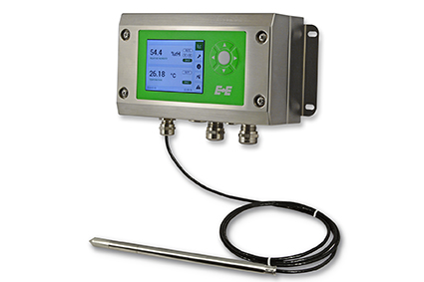 | 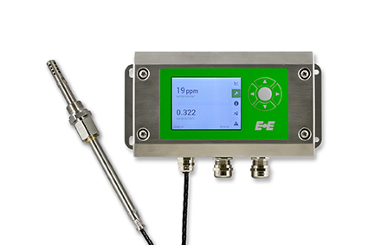
Image 1: EE310 humidity and temperature transmitter for demanding industrial applications. | Image 2: EE360 moisture in oil transmitter for oil condition monitoring.

Photos: E+E Elektronik GmbH, reprint free of charge

E+E Elektronik develops and manufactures sensors and transmitters for humidity, temperature, dewpoint, moisture in oil, air velocity, flow and CO₂. Data loggers, hand-held measuring devices and calibration systems complete the comprehensive product portfolio of the Austrian sensor specialist. The main applications for E+E products lie in HVAC, building automation, industrial process control and the automotive industry. A certified quality management system according to ISO 9001 and IATF 16949 ensures the highest quality standards. E+E Elektronik has a worldwide dealership network and representative offices in Germany, France, Italy, Korea, China and the United States. The accredited E+E calibration laboratory (OEKD) has been commissioned by the Austrian Federal Office for Metrology (BEV) to provide the national standards for humidity and air velocity.

E+E Elektronik Ges.m.b.H
Langwiesen 7
4209 Engerwitzdorf
Austria
T: +43 (0) 7235 605-0
F: +43 (0) 7235 605-8
info@epluse.at
www.epluse.com

Press contact:
Mr. Johannes Fraundorfer
T: +43 (0)7235 605-217
pr@epluse.at

