Differential Pressure Sensor Rounds Up HVAC Portfolio
The EE600 is a versatile, multi-range pressure transmitter for HVAC applications. It is fully configurable and features a large graphic display.

(Engerwitzdorf, 2.7.2018) The EE600 differential pressure sensor extends the product portfolio for HVAC and building automation of the Austrian sensor manufacturer E+E Elektronik. The transmitter is available with full scale 1,000 Pa (4 inch water column) and 10,000 Pa (40 inch WC) with each four selectable measurement ranges. The piezo-resistive pressure sensing element ensures highly accurate and long-term stable measurements. The innovative enclosure facilitates mounting and minimizes installation costs. An optional graphic display shows the actual measured data.

The EE600 is dedicated for the measurement of differential air pressure in ventilation and air conditioning systems or for filter monitoring. Additionally, it can be employed for all non-flammable and non-aggressive gases.

Multi-Range, Fully Configurable
Four measuring ranges (0...250 / 500 / 750 / 1000 Pa or 0...2500 / 5000 / 7500 / 10000 Pa) can be selected via DIP-switches on the electronics board. This makes the EE600 particularly versatile. The output signal and the response time can also be set directly on the board. With push buttons, the user can easily perform a zero and span point adjustment.

Large Graphic Display
The EE600 offers voltage and current output signals, both simultaneously available at the spring terminals. The device can be fitted with a large graphic display. The display backlight and the pressure unit (Pa, mbar, inch WC, kPa) can also be set via DIP-switches on the electronics board.

Installation-Friendly Enclosure
Same as all other HVAC measuring instruments from E+E Elektronik, the EE600 features a robust IP65 / NEMA 4 enclosure, which facilitates fast and easy installation. Due to external mounting holes, it can be mounted with closed cover. This saves time and minimizes installation costs. In addition, the electronics is protected against construction site pollution during installation. For US requirements the enclosure provides a knockout for a 1/2" conduit fitting.

One Stop Solution for HVAC
The EE600 pressure sensor rounds up the existing E+E offer for humidity, temperature, CO₂ and air velocity. E+E Elektronik is thus a single source of measuring devices for all HVAC-relevant measurands.

Characters (incl. spaces): 2411
Words: 363

Images:

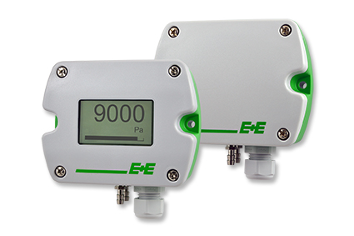
EE600 differential pressure sensor for HVAC and building automation.

Photos: E+E Elektronik GmbH, reprint free of charge

E+E Elektronik develops and manufactures sensors and transmitters for humidity, temperature, dewpoint, moisture in oil, air velocity, flow and CO₂. Data loggers, hand-held measuring devices and calibration systems complete the comprehensive product portfolio of the Austrian sensor specialist. The main applications for E+E products lie in HVAC, building automation, industrial process control and the automotive industry. A certified quality management system according to ISO 9001 and ISO/TS 16949 ensures the highest quality standards. E+E Elektronik has a worldwide dealership network and representative offices in Germany, France, Italy, Korea, China and the United States. The accredited E+E calibration laboratory (OEKD) has been commissioned by the Austrian Federal Office for Metrology (BEV) to provide the national standards for humidity and air velocity.

E+E Elektronik Ges.m.b.H
Langwiesen 7
4209 Engerwitzdorf
Austria
T: +43 (0) 7235 605-0
F: +43 (0) 7235 605-8
info@epluse.at
www.epluse.com

Press contact:
Mr. Johannes Fraundorfer
T: +43 (0)7235 605-217
pr@epluse.at

