HVAC Air Flow Transmitter with Digital Interface
The EE650 air flow transmitter is now available with RS485 interface and Modbus RTU or BACnet MS/TP protocol.

(Engerwitzdorf, 27.08.2018) The EE650 air flow transmitter from E+E Elektronik is dedicated for building automation and process control. The highly accurate device allows for reliable control of the air velocity in ventilation ducts and air conditioning systems. Besides the version with analogue output, the transmitter offers now RS485 interface and Modbus or BACnet protocol.

The EE650, available for duct mount as well as with remote sensing probe, measures air velocity up to 20 m/s (4000 ft/min). The new version features RS485 interface with Modbus RTU or BACnet MS/TP protocol, which facilitates the integration into a bus system. The EE650 with analogue output provides the measured data either as current or voltage signal. The measuring range, the output signal and the response time are user selectable.

Robust, Pollution-Resistant Sensing Element
The E+E air flow sensing element employed in EE650 operates on the hot-film anemometer principle. State-of-the-art transfer molding technology gives the thin-film sensor a high mechanical stability. Due to its innovative flow profile, the sensing element is particularly resistant to contamination, which leads to excellent measurement accuracy and long-term stability.

Easy Installation and Adjustment
The functional IP65 / NEMA 4 enclosure and the mounting flange included in the scope of supply facilitate the installation of the transmitter.

With an optional adapter cable and the free EE-PCS product configuration software, the user can adjust the EE650, set the output scale and select the interface parameters.

Characters (incl. spaces): 1729
Words: 258

Images:
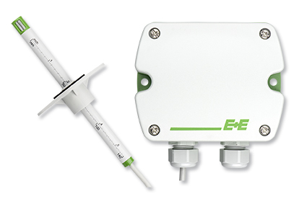

Image: The EE650 air flow transmitter now features an RS485 interface with Modbus or BACnet protocol.

Photos: E+E Elektronik GmbH, reprint free of charge

E+E Elektronik develops and manufactures sensors and transmitters for humidity, temperature, dew point, moisture in oil, air velocity, flow, CO₂ and pressure. Data loggers, hand-held measuring devices and calibration systems complete the comprehensive product portfolio of the Austrian sensor specialist. The main applications for E+E products lie in HVAC, building automation, industrial process control and the automotive industry. A certified quality management system according to ISO 9001 and ISO/TS 16949 ensures the highest quality standards. E+E Elektronik has a worldwide dealership network and representative offices in Germany, France, Italy, Korea, China and the United States. The accredited E+E calibration laboratory (OEKD) has been commissioned by the Austrian Federal Office for Metrology (BEV) to provide the national standards for humidity and air velocity.

E+E Elektronik Ges.m.b.H
Langwiesen 7
4209 Engerwitzdorf
Austria
T: +43 (0) 7235 605-0
F: +43 (0) 7235 605-8
info@epluse.at
www.epluse.com

Press contact:
Mr. Johannes Fraundorfer
T: +43 (0)7235 605-217
pr@epluse.at

