Laminar Flow Sensor with Digital Output
The EE660 air flow sensor, ideal for monitoring very low air velocity, is now also available with an RS485 interface.

(Engerwitzdorf, 7.11.2018) The EE660 from E+E Elektronik measures accurately very low air velocity. It is ideal for laminar flow monitoring and clean room applications. The transmitter is now also available with an RS485 interface.

The EE660 is suitable for accurate measurement of very low air velocity down to 0.15 m/s (30 ft/min). It features an E+E hot film sensing element, which offers excellent long-term stability and short response time. Furthermore, the sensing element is highly resistant to contamination and has a low angular dependency.

Additionally to current and voltage outputs, the device now features an RS485 interface with Modbus RTU or BACnet MS/TP protocol, which allows for easy integration into a bus system.

The EE660 is available for duct mount or with remote probe. The enclosure with external mounting holes facilitates installation with closed cover.

The measured data is also available on the optional display. Backlight and 180° rotatability allow for comfortable reading independent of the mounting conditions.

The EE660 is user configurable with jumpers on the electronics board or via software. The adjustment and the display setup can be performed with an optional configuration adapter and the free EE-PCS Product Configuration Software.

Characters (incl. spaces): 1426
Words: 219

Images:

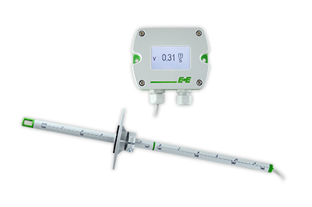
EE660 air velocity sensor with remote probe.

Photos: E+E Elektronik GmbH, reprint free of charge

E+E Elektronik develops and manufactures sensors and transmitters for humidity, temperature, dew point, moisture in oil, air velocity, flow, CO₂ and pressure. Data loggers, hand-held measuring devices and calibration systems complete the comprehensive product portfolio of the Austrian sensor specialist. The main applications for E+E products lie in HVAC, building automation, industrial process control and the automotive industry. A certified quality management system according to ISO 9001 and IATF 16949 ensures the highest quality standards. E+E Elektronik has a worldwide dealership network and representative offices in Germany, France, Italy, Korea, China and the United States. The accredited E+E calibration laboratory (OEKD) has been commissioned by the Austrian Federal Office for Metrology (BEV) to provide the national standards for humidity and air velocity.

E+E Elektronik Ges.m.b.H
Langwiesen 7
4209 Engerwitzdorf
Austria
T: +43 (0) 7235 605-0
F: +43 (0) 7235 605-8
info@epluse.at
www.epluse.com

Press contact:
Mr. Johannes Fraundorfer
T: +43 (0)7235 605-217
pr@epluse.at

