3-in-1 Sensor for CO₂, Humidity and Temperature
The EE850 combines CO₂, humidity and temperature measurement in a single device. The sensor is optimized for building automation and process control.

(Engerwitzdorf, 26.09.2018) The duct mount EE850 from E+E Elektronik measures CO₂ concentration up to 10000 ppm (1 %), as well as relative humidity (RH) and temperature (T). It is ideal for demand controlled ventilation, building automation and also for climate and process control. The 3-in-1 sensor features a dew point temperature (Td) and a passive temperature output.

Long-Term Stable CO₂ Measurement
The EE850 incorporates the E+E dual wavelength NDIR CO₂ sensor, which is highly insensitive to pollution. The CO₂ autocalibration ensures excellent long-term stability, while the temperature compensation leads to high measurement accuracy over the entire working range from -20 to 60 °C (-4...140 °F). The CO₂ sensing cell is located in the innovative device enclosure and thus very well protected.

Outstanding RH Measurement Performance
The combined RH/T sensing element is placed inside the probe. The E+E proprietary coating protects the sensing element from dust and corrosion, which leads to accurate measurement even in harsh environment. It also improves the long-term stability by preventing stray impedances caused by deposits on the active sensor surface.

Analogue Outputs and Passive T Output
The CO₂, RH, T and Td measured data is available on the analogue outputs. Additionally, the EE850 features a passive T output. Configuration and adjustment can be easily performed with an optional adapter and the free EE-PCS configuration software.

Easy Mounting
External mounting holes allow for mounting the transmitter with closed cover. This saves time and protects the electronics from construction site pollution. Alternatively, the device can be installed with the mounting flange included in the scope of supply.

Characters (incl. spaces): 1921
Words: 288

Images:
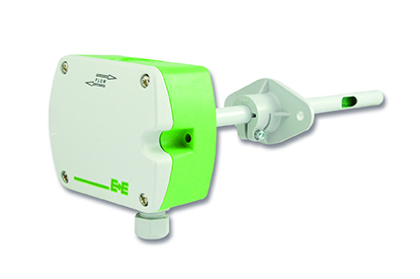
EE850 duct mount transmitter for CO₂, humidity, temperature

Photos: E+E Elektronik GmbH, reprint free of charge

E+E Elektronik develops and manufactures sensors and transmitters for humidity, temperature, dew point, moisture in oil, air velocity, flow, CO₂ and pressure. Data loggers, hand-held measuring devices and calibration systems complete the comprehensive product portfolio of the Austrian sensor specialist. The main applications for E+E products lie in HVAC, building automation, industrial process control and the automotive industry. A certified quality management system according to ISO 9001 and IATF 16949 ensures the highest quality standards. E+E Elektronik has a worldwide dealership network and representative offices in Germany, France, Italy, Korea, China and the United States. The accredited E+E calibration laboratory (OEKD) has been commissioned by the Austrian Federal Office for Metrology (BEV) to provide the national standards for humidity and air velocity.

E+E Elektronik Ges.m.b.H
Langwiesen 7
4209 Engerwitzdorf
Austria
T: +43 (0) 7235 605-0
F: +43 (0) 7235 605-8
info@epluse.at
www.epluse.com

Press contact:
Mr. Johannes Fraundorfer
T: +43 (0)7235 605-217
pr@epluse.at

