CO₂ Probe Resistant to Hydrogen Peroxide
With a special filter cap, the EE871 CO2 probe can now be employed in applications with periodical cleaning and sterilization with hydrogen peroxide (H₂O₂).

(Engerwitzdorf, 18.01.2018) The digital EE871 probe from E+E Elektronik measures CO₂ concentrations up to 50,000 ppm (5 % CO₂). The compact probe is now available with a special filter cap which ensures high accuracy and long-term stability in H₂O₂ contaminated environment. This opens up new applications for the EE871, particularly in the pharmaceutical and biotech industries, where hydrogen peroxide is used for cleaning and sterilization purposes.

The EE871 is a high accuracy CO₂ probe for demanding applications. The IP65 enclosure and replaceable filter caps make it suitable for use in harsh environments. With the new filter cap, the measuring electronics are optimally protected against hydrogen peroxide.

The CO₂ infrared measuring principle (NDIR dual-wavelength technology) of the EE871 is inherently insensitive to contamination. The auto-calibration compensates for ageing effects and provides excellent long-term stability. Thanks to the multi-point CO₂ and temperature adjustment, the EE871 offers a high measuring accuracy over the entire temperature range from -40 °C to 60 °C (-40...140 °F).

The measured values are optionally available on the Modbus RTU interface (up to 10,000 ppm) or the E2 interface (up to 50,000 ppm). The compact design, the electrical connection via M12 plug and the optional mounting flange facilitate quick installation and replacement of the EE871. With a radiation shield, the probe can be also installed outdoors.

The CO₂ probe is additionally available as a set with a conversion board and a connection cable up to 10 m long. The conversion board features an analog output (current/voltage) as well as a Modbus RTU interface and allows easy integration into the application.

Configuration and adjustment of the probe can be performed comfortably with the optional adapter kit.

Characters (incl. spaces): 2021
Words: 306

Images:
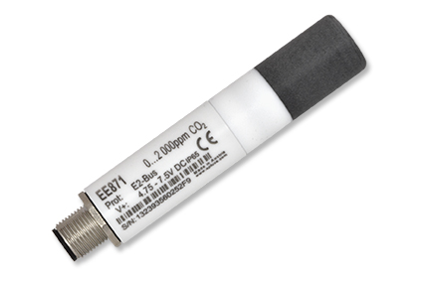 | 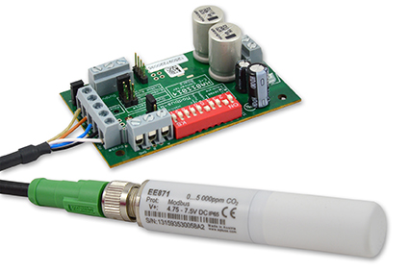
Image 1: The EE871 CO₂ sensor is highly resistant to hydrogen peroxide. | Image 2:  EE871 CO₂ probe with conversion board.

Photos: E+E Elektronik GmbH, reprint free of charge

E+E Elektronik develops and manufactures sensors and transmitters for humidity, temperature, dewpoint, moisture in oil, air velocity, flow and CO₂. Data loggers, hand-held measuring devices and calibration systems complete the comprehensive product portfolio of the Austrian sensor specialist. The main applications for E+E products lie in HVAC, building automation, industrial process control and the automotive industry. A certified quality management system according to ISO 9001 and ISO/TS 16949 ensures the highest quality standards. E+E Elektronik has a worldwide dealership network and representative offices in Germany, France, Italy, Korea, China and the United States. The accredited E+E calibration laboratory (OEKD) has been commissioned by the Austrian Federal Office for Metrology (BEV) to provide the national standards for humidity and air velocity.

E+E Elektronik Ges.m.b.H
Langwiesen 7
4209 Engerwitzdorf
Austria
T: +43 (0) 7235 605-0
F: +43 (0) 7235 605-8
info@epluse.at
www.epluse.com

Press contact:
Mr. Johannes Fraundorfer
T: +43 (0)7235 605-217
pr@epluse.at

