Miniature CO₂ Sensor Module Measures Four Climate Parameters
The new EE895 sensor for CO₂, relative humidity, temperature and pressure is the highlight at the E+E Elektronik booth at Electronica.

(Engerwitzdorf, 9.10.2018) The Austrian sensor specialist E+E Elektronik presents its new EE895 digital miniature sensor for CO₂, relative humidity, temperature and ambient pressure at Electronica Munich, Nov. 13 – 16, 2018. Temperature and pressure compensation ensures high CO₂ measurement accuracy under changing ambient conditions. Digital interfaces facilitate the design-in of the module. At the E+E booth B3-411 the visitors can learn also about E+E sensing elements for humidity, temperature and air velocity as well as about the company's portfolio of measurement devices.

EE895 CO₂ Sensor with Pressure Compensation
The EE895 measures CO₂ concentration up to 10000 ppm (1 % CO₂). The dual wavelength NDIR technology is particularly long-term stable and insensitive to contamination. The factory multipoint CO₂ and temperature adjustment leads to highly accurate CO₂ measurement over a wide temperature range of -40...+85 °C (-40...185 °F).

The influence of the ambient pressure on the CO₂ measurement is automatically compensated using the on-board pressure sensor. The EE895 is therefore ideal for devices exposed to weather changes or operated at various altitudes.

The small dimensions of only 30 x 15 x 8 mm, the choice of mounting options, very low power consumption as well as I²C and UART interfaces facilitate the design-in of the sensor.

Sensing Elements for Humidity, Temperature and Air Velocity
In addition to the EE895, further sensing elements will be presented at the E+E stand:

- EEH110/210 - The digital humidity and temperature sensors with I²C, PWM, PDM, SPI interface, analog voltage output and 3 V or 5 V supply stand for best performance and long-term stability even in demanding environment.
- HMC03M - The humidity sensor for radiosondes is dedicated for weather observation in the upper atmosphere. An integrated heating resistor ensures excellent measuring performance and a short response time under condensation and icing conditions.
- HCT01 / HC109 - The SMD capacitive humidity sensors combine high-quality, long-term proven E+E thin-film sensor technology with easy handling allow for cost-effective signal processing.
- VTQ - The flow sensor works on the hot film anemometer principle. Due to its innovative flow profile it is particularly resistant to contamination. State-of-the-art transfer molding technology gives the thin-film sensor a high mechanical stability.
Comprehensive Measuring Instruments Portfolio
Measuring instruments from E+E Elektronik can be used in a wide range of applications, such as automotive, industrial process control, meteorology or building automation. The portfolio presented at the Electronica includes sensors and transmitters for humidity, temperature, dew point, CO₂, air velocity, mass flow, moisture in oil as well as differential pressure.

Characters (incl. spaces): 3007
Words: 440

Images:
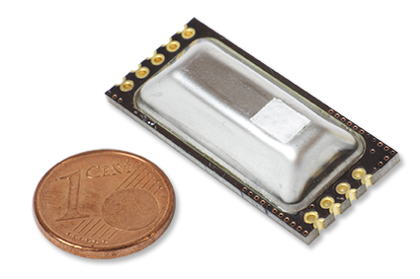 | 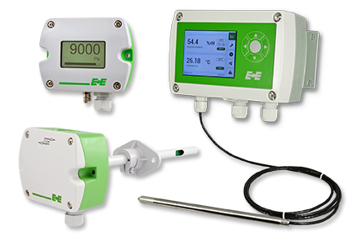
Image 1: The new EE895 measures CO₂, relative humidity, temperature and ambient pressure. | Image 2: E+E measuring instruments for humidity/temperature, CO₂ and differential pressure.

Photos: E+E Elektronik GmbH, reprint free of charge

E+E Elektronik develops and manufactures sensors and transmitters for humidity, temperature, dew point, moisture in oil, air velocity, flow, CO₂ and pressure. Data loggers, hand-held measuring devices and calibration systems complete the comprehensive product portfolio of the Austrian sensor specialist. The main applications for E+E products lie in HVAC, building automation, industrial process control and the automotive industry. A certified quality management system according to ISO 9001 and IATF 16949 ensures the highest quality standards. E+E Elektronik has a worldwide dealership network and representative offices in Germany, France, Italy, Korea, China and the United States. The accredited E+E calibration laboratory (OEKD) has been commissioned by the Austrian Federal Office for Metrology (BEV) to provide the national standards for humidity and air velocity.

E+E Elektronik Ges.m.b.H
Langwiesen 7
4209 Engerwitzdorf
Austria
T: +43 (0) 7235 605-0
F: +43 (0) 7235 605-8
info@epluse.at
www.epluse.com

Press contact:
Mr. Johannes Fraundorfer
T: +43 (0)7235 605-217
pr@epluse.at

