E+E Elektronik Certified According to IATF 16949
The IATF 16949 certification confirms that the Austrian sensor specialist meets the quality requirements of the automotive industry.

(Engerwitzdorf, 20.09.2018) The Austrian sensor manufacturer E+E Elektronik has recently completed the certification according to IATF 16949:2016. It confirms that the company’s quality assurance system complies with the high requirements of the automotive industry. The new standard follows the previous ISO/TS 16949 and is recognised by the world's leading automotive manufacturers.

E+E Elektronik develops and produces sensors and transmitters for humidity, temperature, CO₂, air velocity, dew point, moisture in oil, mass flow and pressure. The highly accurate measurement devices are used all over the world in various applications, such as building automation, process control, meteorology, environmental technology, agriculture and clean rooms.

Humidity Sensors for the Automotive Industry
In the automotive industry, the humidity sensors from E+E Elektronik are part of control systems for the fuel mixture, the air conditioning or the windscreen fogging prevention. For quantities of several millions of units, highest quality level is a must. Therefore, the company has already been certified according to the automotive standard ISO/TS 16949.

"With the IATF certification, E+E Elektronik qualifies as a reliable partner for the automotive industry. This is proof that we strive and are able to offer our customers the highest quality standards", states E+E Managing Director Josef Hartl.

ISO 9001 Certified since 1993
Already 25 years ago, E+E Elektronik established a quality assurance system in compliance with ISO 9001 and thus anchored the quality aspect in the corporate strategy. The company is now certified according to the latest ISO 9001:2015, which is also mandatory for the new IATF standard.

Commitment to Environmental and Climate Protection
Besides innovative products and high quality standards, E+E Elektronik also takes environmental protection and the sustainably use of resources very seriously. Membership in the Austrian Climate Alliance and an environmental management system according to ISO 14001 are therefore a matter of course for the company.

Characters (incl. spaces): 2254
Words: 326

Images:

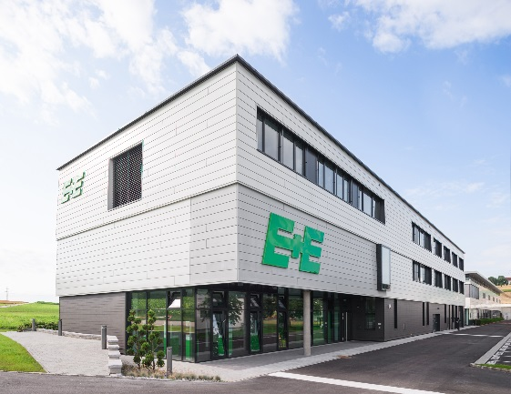
Image 1: The Austrian sensor manufacturer E+E Elektronik now also complies with IATF 16949. | Image 2:  E+E Elektronik Managing Director Josef Hartl

Photos: E+E Elektronik GmbH, reprint free of charge

E+E Elektronik develops and manufactures sensors and transmitters for humidity, temperature, dew point, moisture in oil, air velocity, flow, CO₂ and pressure. Data loggers, hand-held measuring devices and calibration systems complete the comprehensive product portfolio of the Austrian sensor specialist. The main applications for E+E products lie in HVAC, building automation, industrial process control and the automotive industry. A certified quality management system according to ISO 9001 and IATF 16949 ensures the highest quality standards. E+E Elektronik has a worldwide dealership network and representative offices in Germany, France, Italy, Korea, China and the United States. The accredited E+E calibration laboratory (OEKD) has been commissioned by the Austrian Federal Office for Metrology (BEV) to provide the national standards for humidity and air velocity.

E+E Elektronik Ges.m.b.H
Langwiesen 7
4209 Engerwitzdorf
Austria
T: +43 (0) 7235 605-0
F: +43 (0) 7235 605-8
info@epluse.at
www.epluse.com

Press contact:
Mr. Johannes Fraundorfer
T: +43 (0)7235 605-217
pr@epluse.at

